PROFORMA FOR ANNUAL REPORT 2013 (April 2013 to March 2014)

1. GENERAL INFORMATION ABOUT THE KVK

1.1. Name and address of KVK with phone, fax and e-mail

Address | Telephone |  | E mail
Address | Office | FAX | E mail
Darjeeling KVK  Uttar Banga Krishi Viswavidyalaya  Kalimpong, Darjeeling, West Bengal - 734301 | 03552 256283 | 03552 256283 | djkvk@yahoo.com

1.2 .Name and address of host organization with phone, fax and e-mail

Address | Telephone |  | E mail
Address | Office | FAX | E mail
Dr. Himadri Bhattacharya  Uttar Banga Krishi Viswavidyalaya  P.O Pundibari, Cooch Behar | 03582-270141/986 | 03582-270249/986 | Dee_ubkv@yahoo.com

1.3. Name of the Programme Coordinator with phone & mobile No.

Name | Telephone / Contact
Name | Residence | Mobile | Email
Dr. Mendel Wangchuk Moktan |  | 9635105595 | mendelmw@gmail.com

1.4. Year of sanction of KVK: 1993

1.5. Staff Position (as on 1st April, 2014)

Sl.  No. | Sanctioned post | Name of the incumbent | Designation | Discipline | Pay  Scale with present basic | Date of joining | Permanent  /Temporary | Category (SC/ST/  OBC/  Others)
1 | Programme  Coordinator | Dr. Mendel Wangchuk Moktan | Programme Coordinator  (In-charge) | Agril. Extension | Salary from the University | 10.12.2001 | Permanent | ST
2 | Subject Matter  Specialist | Dr. Sajeed Ali | Lecturer | Plant Pathology | Salary from the University | 11.03.2003 | Permanent | General
3 | Subject Matter  Specialist | Dr. Tapas Kumar Pandit | SMS | Soil Science | PB-3  22950 | 14.06.2011 | Permanent | SC
4 | Subject Matter  Specialist | Dr. Ramkrishna Sarkar | SMS | Horticulture | PB-3  22950 | 30.08.2011 | Permanent | SC
5 | Subject Matter  Specialist | Dr. Rakesh Roy | SMS | Animal Science | PB-3  28688 | 29.06.2011 | Permanent | SC
6 | Computer  Programmer | Sri. Subrata Manna | Programme Assistant (Comp) | M.C.A | PB – 2  17780 | 30.01.2006 | Permanent | OBC
7 | Programme Assistant | Sri Basu Deo Kharga | Programme Assistant (Training) | Agril. Extension | PB-2  17260 | 20.06.2007 | Permanent | General
8 | Farm Manager | Akash Deep Thapa | Farm Manager | Agril. Extension | PB-2  17260 | 02.07.2007 | Permanent | OBC
9 | Accountant / Superintendent | Mr. Puspalal Chhetri | Assistant | B.Com | 9500 | 8.12.2011 | Consolidated | General
10 | Stenographer | Palash Das | Steno Gr-III | B.Com | PB – 1  12210 | 29.06.2006 | Permanent | General
11 | Driver | Ashok Tamang  Driver | Driver | HS | PB – 1  9530 | 12.09.2007 | Permanent | ST
12 | Driver | Nirmal Bagdas | Sr. Driver | VIII | Salary from the University | 23.08.1996 | Permanent | SC
13 | Supporting staff | Sri. Netra Prasad Sharma | Lab Attendant | M.P | Salary from the University | 05.04.1999 | Permanent | General
14 | Supporting staff | Sri. DipakTamang | Cook | VIII | Salary from the University | 05.04.1999 | Permanent | ST

1.6. Total land with KVK (in ha) : 22.4 ha

S. No. | Item | Area (ha)
1 | Under Buildings | 0.25
2. | Under Demonstration Units | 1.00
3. | Under Crops | 2.50
4. | Orchard/Agro-forestry | 1.88
5. | Others with details | 16.77
 | Total | 22.4
Total area should be matched with breakup

1.7. Infrastructure Development:

A) Buildings and others

S. No. | Name of building | Not yet started | Completed up to plinth level | Completed up to lintel level | Completed up to roof level | Totally completed | Plinth area (sq.m) | Under use or not* | Source of funding
1. | Administrative  Building |  |  |  |  | April 2004 | 293 | Yes | ICAR
2. | Farmers Hostel |  |  |  |  | 31/03/2006 | 293 | Yes | ICAR
3. | Staff Quarters (6) |  |  |  |  | 31/03/2009 | 400 | 4 out of 6 | ICAR
4. | Piggery unit |  |  |  |  | 31/03/2012 | 14 | Not | RKVY Project
5 | Fencing
6 | Rain Water harvesting structure |  |  |  |  | 31/03/2009 | 75000 L | Yes | ICAR
7 | Threshing floor |  |  |  |  | 31/03/2012 | 400 sq ft | Yes | RKVY Project
8 | Farm godown |  |  |  |  | 31/03/2010 | 800 Sq ft | Yes | ICAR
9. | Dairy unit
10. | Poultry unit |  |  |  |  | 31/03/2012 | 450 Sq ft | No | RKVY Project
11. | Goatery unit |  |  |  |  | 31/03/2012 | 120 Sq ft | No | RKVY Project
12. | Mushroom Lab
13. | Mushroom production unit |  |  | Under construction
14. | Shade house |  |  |  |  | 31/03/2012 | 800 Sq ft | No | RKVY Project
15. | Soil test Lab |  |  |  |  | University’s building | 180 Sq ft | Yes | University
16 | Bio fertilizer unit |  |  |  |  | 31/03/2012 | 300 sq ft | No | RKVY Project

* If not in use then since when and reason for non-use

B) Vehicles

Type of vehicle | Year of purchase | Cost (Rs.) | Total km. Run | Present status
Mahendra Max (4 wheel drive) | 2006 | 5.0 lakhs | 139962 | Poor

C) Equipment & AV aids

Name of equipment | Year of purchase | Cost (Rs.) | Present status | Source of fund
a. Lab equipment
Spectrophotometer |  | 0.60 |  | ICAR
Flame Photometer |  | 0.50 |  | ICAR
PH Meter |  | 0.10 |  | ICAR
Conductivity bridge |  | 0.10 |  | ICAR
Physical balance |  | 0.10 |  | ICAR
Chemical balance |  | 1.00 |  | ICAR
Digestion unit |  |  |  | ICAR
Kjeldhal Distillation set |  | 0.60 |  | ICAR
Mechanical shaker |  | 0.50 |  | ICAR
Refrigerator |  | 0.20 |  | ICAR
Hot air oven |  | 0.15 |  | ICAR
Hot plate |  | 0.25 |  | ICAR
Grinder |  | 0.30 |  | ICAR
Water distillation unit (double) |  | 1.00 |  | ICAR
Chemical and Glass wares |  | 2.50 |  | ICAR
Soxlet Apparatus (Big &Small) |  | 0.50 |  | ICAR
Laboratory set up |  | 3.30 |  | ICAR
Soil and plant sample processing and storage facility |  | 0.50 |  | ICAR
b. Farm machinery
Power tiller | (2 nos) one from RRS, Hill Zone & another from Khoribari | One is in working condition another working but need some repairing
Rotary power tiller | 2011 | 68500 | working | RKVY
Weed cutter | 2011 | 32800 | Working | RKVY
Mobile sprayer | 2011 | 32600 | Working | RKVY
Rocker sprayer | 2011 | 4800 | Working | RKVY
Branch cutter | 2011 | 61000 (2nos) | Working | RKVY
Paddy cutter | 2011 | 36000 | working | RKVY
Weigh machine | 2011 | 16640(2nos) | Working | RKVY
P.A. System | 2011 | 2860 | working | RKVY
c. AV Aids
Over Head Projector | 1995 | 9042 | Not good
Television | 2004 | 13500 | Good
DVD | 2006 | 4050 | Good
Camera | 1994 | 2350 | Not good
Digital Camera Sony F217 | 2004 | 64990 | Not good
LCD Projector | 2008 | 78000 | Good
LCD Projector | 2009 | 56000 | Good
Nikon SLR Camera | 2009 | 30000 | Not Good
Handy Cam | 2009 | 25000 | Not Good
Laptop | 2009 | 30000 | outdated
Laptop | 2011 | 30000 | Not Good
Netbook | 2011 | 25000 | Good
Ahuja Sound system for Conference Hall |  |  | Good
Canon Photo copier |  |  | Good
FAX Machine |  |  | Good
Laptop | 2011 | 44780 | Working
Desktop | 2011 | 40980 | Working
LCD Projector | 2011 | 54000 | Working
Printer | 2011 | 10900 | Working
UPS | 2011 | 1750 | working

D) Farm implements

Name of equipment | Year of purchase | Cost (Rs.) | Present status | Source of fund
Maize Sheller | 2011 | 1500 (10 pcs) | Working | ICAR
Secateurs | 2011 | 2100 (6pcs) | Working | RKVY
Tree pruner | 2011 | 1645 (1pc) | Working | RKVY
Hedge shear | 2011 | 1000 (1pc) | Working | RKVY
Pruning saw | 2011 | 400 (2pcs) | Working | RKVY
Garden tools | 2011 | 1200 (3 pcs) | Working | RKVY
Spade | 2011 | 3750 (12 pcs) | Working | RKVY
Rake | 2011 | 1344 (6 pcs) | Working | RKVY
Khurpa | 2011 | 900 (8 pcs) | Working | RKVY
Datri | 2011 | 375 (3pcs) | Working | RKVY
Knapsack sprayer | 2011 | 5100 (2 pcs) | Working | RKVY

1.8. A). Details SAC meeting* conducted in the year

Sl.No. | Date | Number of Participants | Salient Recommendations | Action taken | If not conducted, state reason
1. | 06/02/2014 | 33 | The number of participants in training is low, it should be at least 2500 as per the ICAR guidelines. | To be taken
2 |  |  | Total number of farmers in trainings should be increased to 1500 by march 2014 | To be taken
3 |  |  | Training on mushroom cultivation should be conducted. | To be taken
4 |  |  | There should be an abstract of FLD (No. of farmer, land size etc) during presentation | To be taken
5 |  |  | Photograph of local check in FLD should be given during presentation | To be taken
6 |  |  | The photographs of all the treatments (Technology option ) and farmers practice should be given in report and during presentation. | To be taken
7 |  |  | The source of technology should be mentioned in OFT | To be taken
8 |  |  | The OFT on boron application on Toria should be directly taken to FLD, because the source of technology is RRS (HZ). Any technology developed by RRS (HZ) should be directly taken to the FLD | To be taken
9 |  |  | The OFT in blight management of Large cardamom is excellent, it should be taken to FLD. | To be taken
10 |  |  | Banaraja is an established good breed, take it to FLD and design new FLD. | To be taken
11 |  |  | Website should be updated immediately, all the activities of Kendra should be uploaded in website. | To be taken
12 |  |  | Whenever new PC joins, ongoing PC should inform him about the latest recommendation/ instruction during handing over and taking over of charges. | To be taken
13 |  |  | Exposure visit of farmers should be conducted | To be taken
14 |  |  | KVK should organize other extension activities like Krishi mela, Ex trainees sammelan, field days, Technology week etc. | To be taken
15 |  |  | Farmers club and SHG for farmwomen should be organized. | To be taken
* Salient recommendation of SAC in bullet form
Attach a copy of SAC proceedings along with list of participants

2. District level data on agriculture, livestock and farming situation (2013-14)

Sl. no. | Item | Information
1 | Major Farming system/enterprise | Hill and mountain farming system with horticulture base crop enterprise
2 | Agro-climatic Zone
 | Hill Zone | - Sloppy land – high soil erosion, shallow depth  - Acidity problem  - Low soil fertility – due to NPK and micro nutrient  - Low Nitrogen release from organic matter due to soil acidity and low temperature
 | Tarai Zone | - High leaching loss of nutrient due to light texture soil  - Low availability of P due to soil acidity  - Bo and Mo deficiency
3 | Agro ecological situation | - Due to sub-humid climate organic matter content moderate to high (2%) but decrease with depth  - The eastern Himalayan region acidic to neutral range pH found
4 | Soil type
 | Brown forest soil | - Slow release nutrients from organic matter due to acidity and low temperature  - Micro nutrient deficiency  - Leaching loss of nutrients due to high rainfall
5 | Productivity of major 2-3 crops under cereals, pulses, oilseeds, vegetables, fruits and others | Crop | Productivity (q/ha)
5 |  | Rice | 16.98
5 |  | Wheat | 13.18
5 |  | Maize | 20.42
5 |  | Gram | 10.65
5 |  | Other Pulses | 6.19
5 |  | Mustard | 3.01
5 |  | Linseed | 2.05
5 |  | Potato | 164.40
5 |  | Tea | 18.89
5 |  | Chilli (dry) | 7.5
5 |  | Ginger | 35
5 |  | Mandarin Orange | 92
5 |  | Tomato | 160.79
5 |  | Cabbage | 340.21
5 |  | Cauliflower | 343.55
5 |  | Radish | 135.04
5 |  | Gladiolus | 146733 spikes
6 | Mean yearly temperature, rainfall, humidity of the district
  Month | Rainfall (mm) | Temperature ⁰ C |  | Relative Humidity (%)
  Month | Rainfall (mm) | Maximum | Minimum | Relative Humidity (%)
  April 13 | 11.0 | 23.5 | 21.4 | 90
  May 13 | 23.1 | 26.6 | 23.8 | 91
  June 13 | 298.4 | 21.3 | 19.9 | 96
  July 13 | 478.3 | 22.3 | 21.5 | 97
  Aug 13 | 463.0 | 22.4 | 21.7 | 94
  Sept 13 | 488.0 | 21.7 | 20.3 | 91
  Oct 13 | 38.0 | 18.5 | 15.5 | 86
  Nov 13 | 6.5 | 16.3 | 15.3 | 79
  Dec 13 | 0 | 12.1 | 8.9 | 73
  Jan 14 | 7.5 | 9.3 | 7.2 | 83
  Feb 14 | 4.0 | 11.2 | 9.1 | 71
  Mar 14 | 6.0 | 17.7 | 16.5 | 62
7 | Production of major livestock products like milk, egg, meat etc. | Category |  | Population
7 |  | Cattle
7 |  | Crossbred |  | 277057
7 |  | Indigenous
7 |  | Buffalo |  | 5520
7 |  | Sheep
7 |  | Crossbred |  | 2649
7 |  | Indigenous
7 |  | Goats |  | 187975
7 |  | Pigs |  | 53875
7 |  | Crossbred
7 |  | Indigenous
7 |  | Rabbits
7 |  | Poultry |  | 673026
7 |  | Hen
7 |  | Desi
7 |  | Improved
7 |  | Duck
7 |  | others |  | 71593

2.6 Details of operational area / villages (2013-14)

Sl.  No. | Name of Taluk | Name of the block | Name of the villages | Major crops  & enterprises | Major problems identified (crop-wise) | Identified Thrust Areas
1 | Kalimpong | Kalimpong I | Bong Busty | Paddy, Vegetables, Maize, Ginger | Ginger Rhizome rot, low productivity of paddy and vegetables | Rhizome rot disease of ginger
2 |  |  | Charkhol | Large Cardamom, Maize Potato Vegetables | Blight in Large cardamom, potato, low market price for vegetables | Blight in Large cardamom
3 |  | Algarah | Sangsey | Ginger, Maize, Vegetables, Darjeeling Orange | Fruit drop in orange, Rhizome rot in ginger | Fruit drop in orange, Rhizome rot in ginger
4 |  |  | Sakyong | Ginger, Maize, Vegetables, Darjeeling Orange | Fruit drop in orange, Rhizome rot in ginger | Fruit drop in orange, Rhizome rot in ginger
5 | Kurseong | Mirik | Manju | Ginger, Darjeeling Orange, Vegetables | Rhizome rot in ginger, fruit drop and trunk borer in orange and low market rate for vegetables | Fruit drop in orange, Rhizome rot in ginger
6 |  |  | Bungkulung | Darjeeling orange, ginger, Maize, Rice, Vegetable | Rhizome rot in ginger, fruit drop and trunk borer in orange and low market rate for vegetables | Fruit drop in orange, Rhizome rot in ginger
7 | Darjeeling | Darjeeling Pul Bazar | Lower Kizom | Ginger, Maize, Vegetable and Rice | Rhizome rot in ginger, low productivity of vegetables | Rhizome rot of ginger
1 | Kalimpong | Kalimpong I | Bong Busty | Paddy, Vegetables, Maize, Ginger | Ginger Rhizome rot, low productivity of paddy and vegetables | Rhizome rot disease of ginger

2.7 Priority thrust areas

Sl. No | Thrust area
1. | Management of declination of Darjeeling Mandarin orange.
2. | Mulching in Citrus orchard (to conserve soil moisture).
3. | Management of Gladiolus (cut flowers) & Marigold
4. | Production management of Rice.
5. | Production management of Potato.
6. | Promotion of I.P.M. in Rice and Potato.
7. | Introduction of off season vegetables.
8. | Socio-Economic empowerment of women through Preservation, Mushroom production, Backyard Poultry and Goatery.
9. | Entrepreneurship development of rural youth through floriculture, small scale piggery and production of vermi compost.
10. | Production & Management of Large Cardamom.
11. | Production & Management of Maize.

3. TECHNICAL ACHIEVEMENTS

3. A. Details of target and achievement of mandatory activities by KVK during 2013-14@

OFT |  |  |  | FLD
Number of OFTs |  | Number of farmers |  | Number of FLDs |  | Number of farmers
Target | Achievement | Target | Achievement | Target | Achievement | Target | Achievement
8 | 6 | 49 | 37 | 12 | 5 | 218 | 67

Training |  |  |  | Extension activities
Number of Courses |  | Number of Participants |  | Number of activities |  | Number of participants
Target | Achievement | Target | Achievement | Target | Achievement | Target | Achievement
80 | 65 | 2452 | 1985 | 33 | 27 | 2500 | 2319

Seed production (q) |  | Planting material (Nos.)
Target | Achievement | Target | Achievement
 |  | 4000 | Nil

@Target should match with your midterm report
3.1 Achievements on technologies assessed and refined

OFT-1 : Assessment the performance of sulphur application on Toria under rain fed land of brown forest soil, the Hill Zone of Kalimpong, West Bengal. (2013-14)

1. | Title of the OFT | Assessment the performance of sulphur application on Toria under rain fed land of brown forest soil, the Hill Zone of Kalimpong, West Bengal. (2013-14)
2. | Problem diagnose | Poor yield performance of Toria due to application of imbalance Inorganic fertilizer dose
3. | Details of technologies selected for assessment/refinement | Farmers' practice: Farmers practice fertilizer dose @ NPK 80:20:30 Kg per hectare. They use mainly DAP.  Technology Option I: Soil test based application of N, P₂0_{5,}K₂0 ( N in the form of Urea and DAP , P₂O₅ in the form of DAP and K₂O in the form of MOP) + Foliar  Technology Option II: Soil test based application of N, P₂0_{5,}K₂0 ( N in the form of Urea and DAP , P₂O₅ in the form of DAP and K₂O in the form of MOP) + Basal soil application of elemental sulphur (80%) @ 20 kg/ha
4. | Source of Technology | BCKV, Mohanpur, Nadia
5. | Production system and thematic area | Rainfed land of brown forest soil and integrated nutrient management
6. | Performance of the Technology with performance indicators | The performance of the technology option II relating to the indicator such as yield, number of branches/plant, no. of siliqua/plant, etc. were better than farmers’ practice and technology option I.
7. | Final recommendation for micro level situation | Technology option II is recommended for increase in yield of toria in rainfed land of brown forest soil, the Hill zone of Kalimpong.
8. | Constraints identified and feedback for research | Nil
9. | Process of farmers participation and their reaction | Farmers participated through the experiment from planning to execution. They are ready to use the technology recommended for toria production in future.

Thematic area: Rainfed land of brown forest soil and integrated nutrient management
Problem definition: Poor yield performance of Toria due to application of imbalance Inorganic fertilizer dose
Technology assessed: Assessment the performance of sulphur application on Toria under rain fed land of brown forest soil, the Hill Zone of Kalimpong, West Bengal. (2013-14)
Table:
Technology option | No. of trials | Yield component |  |  |  | Disease/ insect pest incidence (%) | Yield  (q/ha) | Cost of cultivation  (Rs./ha) | Gross return (Rs/ha) | Net return  (Rs./ha) | BC ratio
Technology option | No. of trials | No. of branch/  plant | No. of siliqua/ plant | No. of seeds/  siliqua | Test weight (g)
Farmers' practice: Farmers practice fertilizer dose @ NPK 80:20:30 Kg per hectare. They use mainly DAP. | 7 | 7.81 | 65.29 | 21.76 | 33.43 | - | 7.41 | 16450 | 20059 | 3609 | 1.22
Technology Option I: Soil test based application of N, P₂0_{5,}K₂0 ( N in the form of Urea and DAP , P₂O₅ in the form of DAP and K₂O in the form of MOP) + Foliar | 7 | 8.34 | 72.81 | 32.63 | 41.62 | - | 9.21 | 16698 | 24843 | 8145 | 1.49
Technology Option II: Soil test based application of N, P₂0_{5,}K₂0 ( N in the form of Urea and DAP , P₂O₅ in the form of DAP and K₂O in the form of MOP) + Basal soil application of elemental sulphur (80%) @ 20 kg/ha | 7 | 9.78 | 82.12 | 35.51 | 50.11 | - | 10.23 | 17123 | 27562 | 10439 | 1.61

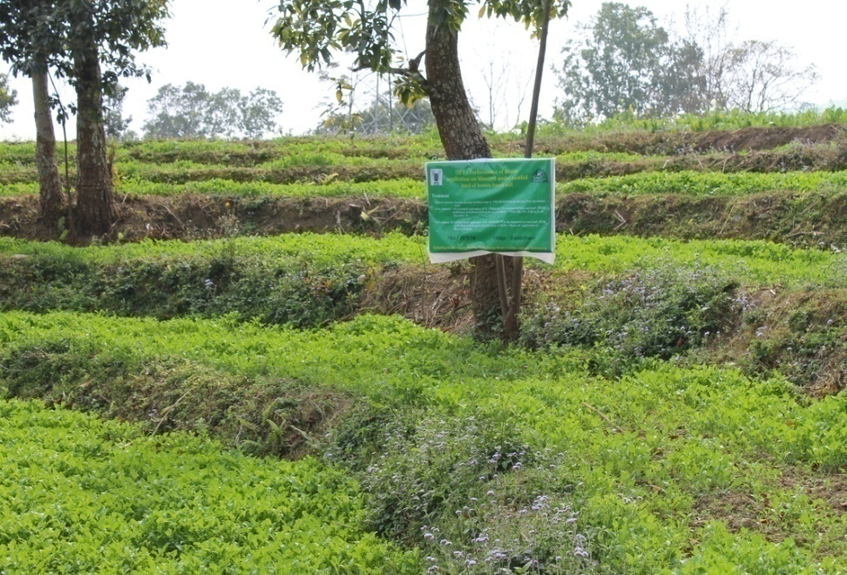
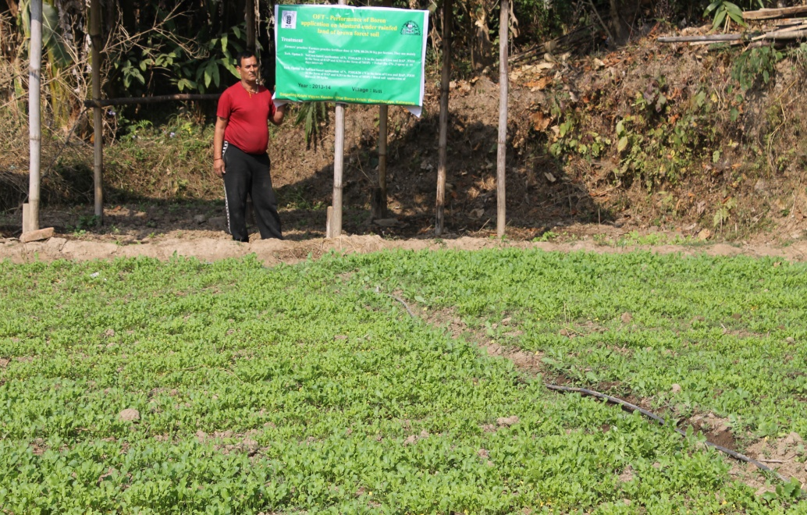
Results: soil testing report
Nutrient content | Initial soil test | After harvesting
OC (%) | 1.84 | 1.97
pH | 5.02 | 5.52
Available N Kg ha⁻¹ | 262 | 281
Available P₂O₅Kg ha⁻¹ | 35 | 47
Available K₂OKg ha⁻¹ | 287 | 310

OFT 2: Assessment the performance of Boron application on Cauliflower under rain fed land of brown forest soil, the Hill Zone of Kalimpong, West Bengal.

1. | Title of the OFT | Assessment the performance of Boron application on Cauliflower under rain fed land of brown forest soil, the Hill Zone of Kalimpong, West Bengal.
2. | Problem diagnose | Poor yield performance of Cauliflower
3. | Details of technologies selected for assessment/refinement | Farmers' practice: Farmers practice fertilizer dose @ NPK 160:40:210 Kg per hectare. They use mainly DAP.  Technology Option I: Soil test based application of N, P₂0_{5,}K₂0 ( N in the form of Urea and DAP , P₂O₅ in the form of DAP and K₂O in the form of MOP) + Foliar(Bo -2% ,3 spray @ 15 days interval)  Technology Option II: Soil test based application of N, P₂0_{5,}K₂0 ( N in the form of Urea and DAP , P₂O₅ in the form of DAP and K₂O in the form of MOP) + Basal soil application Borax@ 20 kg/ha
4. | Source of Technology | RRS (Hill Zone), UBKV, Kalimpong
5. | Production system and thematic area | Rainfed land of brown forest soil and integrated nutrient management
6. | Performance of the Technology with performance indicators | The performance of the technology option II relating to the indicator such as no. of leaves/plant, total curd yield, economics, etc. were better than farmers’ practice and technology option I.
7. | Final recommendation for micro level situation | Technology option II is recommended for increase in yield of cauliflower in rainfed land of brown forest soil, the Hill zone of Kalimpong.
8. | Constraints identified and feedback for research | Nil
9. | Process of farmers participation and their reaction | Farmers participated through the experiment from planning to execution. They are ready to use the technology recommended for toria production in future.

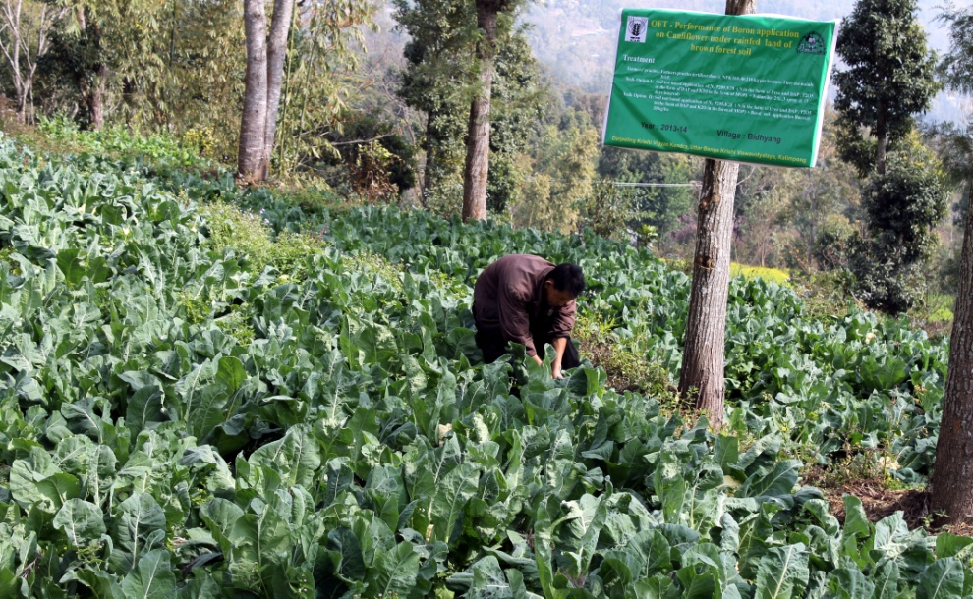
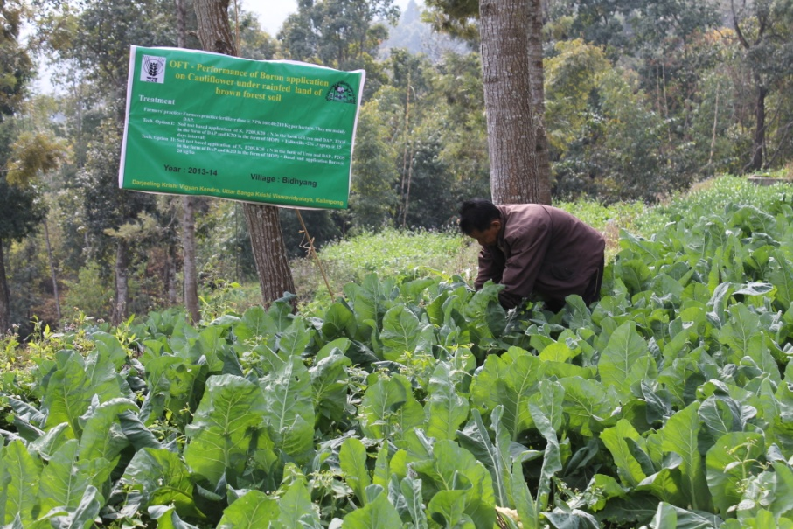

Thematic area: Rainfed land of brown forest soil and integrated nutrient management
Problem definition: Poor yield performance of Cauliflower
Technology assessed: Assessment the performance of Boron application on Cauliflower under rain fed land of brown forest soil, the Hill Zone of Kalimpong, West Bengal.
Table:
Technology option | No. of trials | Yield component |  |  |  | Disease/ insect pest incidence (%) | Yield  (q/ha) | Cost of cultivation  (Rs./ha) | Gross return (Rs/ha) | Net return  (Rs./ha) | BC ratio
Technology option | No. of trials | No. of leaves/  plant | No. of siliqua/ plant | No. of seeds/  siliqua | Test weight (g)
Farmers' practice: Farmers practice fertilizer dose @ NPK 160:40:210 Kg per hectare. They use mainly DAP. | 7 | 16 | - | - | - | - | 140 | 140000 | 294000 | 154000 | 1:2.10
Technology Option I: Soil test based application of N, P₂0_{5,}K₂0 ( N in the form of Urea and DAP , P₂O₅ in the form of DAP and K₂O in the form of MOP) + Foliar(Bo -2% ,3 spray @ 15 days interval) | 7 | 22 | - | - | - | - | 220 | 187045 | 462000 | 274955 | 1:2.47
Technology Option II: Soil test based application of N, P₂0_{5,}K₂0 ( N in the form of Urea and DAP , P₂O₅ in the form of DAP and K₂O in the form of MOP) + Basal soil application Borax@ 20 kg/ha | 7 | 27 | - | - | - | - | 250 | 190909 | 525000 | 334091 | 1:2.75

Results: soil testing report
Nutrient content | Initial soil test | After harvesting
OC (%) | 1.51 | 1.86
pH | 4.92 | 5.25
Available N Kg ha⁻¹ | 241 | 265
Available P₂O₅Kg ha⁻¹ | 41 | 52
Available K₂OKg ha⁻¹ | 321 | 328

OFT 3: Performance of TPS varieties under Hill Agro-climatic situation
1. | Title of the OFT | Performance of TPS varieties under Hill Agro-climatic situation
2. | Problem diagnose | Poor quality potato tuber yields and high cost of cultivation. Non-availability of quality seed tubers, high seed cost, virus infiltration of seed tubers causing degeneration of seed stocks.
3. | Details of technologies selected for assessment/refinement | Farmers’ practice: Darjeeling Red Round (seed tubers) with Farmyard manure @ 5 tonnes/ha.  Tech. option I: H.P.S. I/13 with Farmyard manure @ 20 tonnes/ha + NPK @ 150:100:150 kg/ha (RDF).  Tech. option II: H.P.S. II/13 with Farmyard manure @ 20 tonnes/ha + NPK @ 150:100:150 kg/ha (RDF).  Tech. option III: H.P.S. II/67 with Farmyard manure @ 20 tonnes/ha + NPK @ 150:100:150 kg/ha (RDF).
4. | Source of Technology | Horticultural Research Complex, Nagicherra, West Tripura
5. | Production system and thematic area | Vegetable based cropping systems
6. | Performance of the Technology with performance indicators | Based on the tuber yield and benefit: cost ratio of TPS progenies compared to locally available variety, Darjeeling Red Round, the Technology Option III (HPS II/67) was found to be significant followed by Tech. option I (HPS I/13).
7. | Final recommendation for micro level situation | Among the different TPS progenies, the Technology option III (HPS II/67) was recommended but further trial on commercial production against the farmers’ practices using both these seed tubers and TPS seedlings have to be conducted next year.
8. | Constraints identified and feedback for research | Non-availability of TPS seed materials and lack of awareness about the TPS production technology. That’s why further research and training programmes have to be conducted to standardize the TPS production technology.
9. | Process of farmers participation and their reaction | Farmers participated actively through phone calls, personal contacts, field days, etc. Farmers participated in this programme were highly interested in raising crops from TPS and demanded a larger quantity and a regular supply of TPS for potato production.

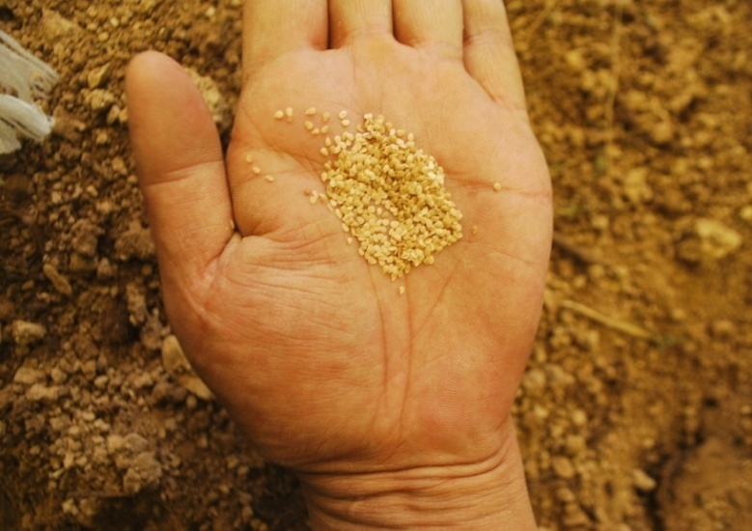
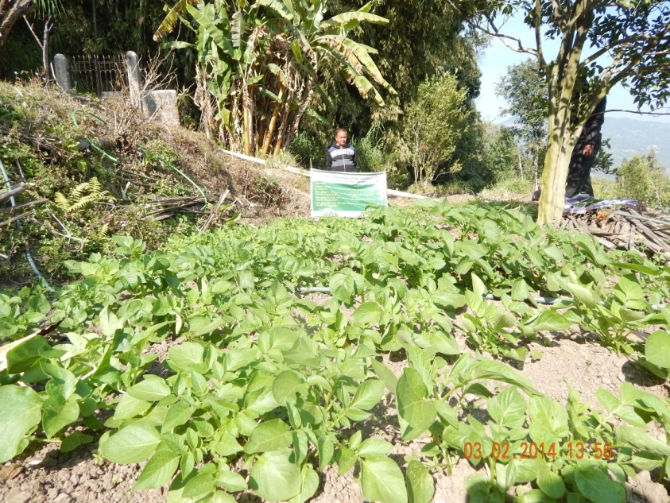

Thematic area: Vegetable based cropping systems
Problem definition: Poor quality potato tuber yields and high cost of cultivation. Non-availability of quality seed tubers, high seed cost, virus infiltration of seed tubers causing degeneration of seed stocks.
Technology assessed: Performance of TPS varieties under Hill Agro-climatic situation
Table 1: Data on parameter in relation to Technology demonstrated (OFT 3)
Technology option | No. of trials | Yield component |  |  | Disease/ insect pest incidence (%) | Yield  (q/ha) | Cost of cultivation  (Rs./ha) | Gross return (Rs/ha) | Net return  (Rs./ha) | B:C ratio
Technology option | No. of trials | Avg. wt. of tuber (g) | No. of spikelet per panicle | Test wt. (100 grain wt.)
Farmers’ practice | 5 | 23.6 | - | - | - | 104.0 | 56216 | 83200 | 26984 | 1.48
Tech. option I:  HPS I/13 | 5 | 25.4 | - | - | - | 159.0 | 51767 | 111300 | 59533 | 2.15
Tech. option II:  HPS II/13 | 5 | 23.9 | - | - | - | 146.0 | 48890 | 102200 | 53310 | 2.09
Tech. option III:  HPS II/67 | 5 | 26.8 | - | - | - | 178.0 | 53248 | 124600 | 71352 | 2.34

Results:
Based on the tuber yield and benefit: cost ratio of TPS progenies compared to locally available variety, Darjeeling Red Round, the Technology Option III (HPS II/67) was found to be significant followed by Tech. option I (HPS I/13). Among the different TPS progenies, the Technology option III (HPS II/67) was recommended but further trial on commercial production against the farmers’ practices using both these seed tubers and TPS seedlings have to be conducted next year.
OFT 4: Assessing the performance of onion (Allium cepa) varieties
1. | Title of the OFT | Assessing the performance of onion (Allium cepa) varieties
2. | Problem diagnose | Poor bulb yield due to repeated use of same local cultivar which causes low bulb yield and occurrence of more disease and pest infestation.
3. | Details of technologies selected for assessment/refinement | Farmers’ practice: Local cultivar with FYM @ 5 tonnes/ha without chemical fertilizer application  Tech. Option I: Nasik Red (N-53) with FYM @ 10 tonnes/ha + 50% NPK of RDF (100:50:100 kg/ha) + vermin-compost @ 2.5 tonnes/ha  Tech. Option II: Red Gold with FYM @ 10 tonnes/ha + 50% NPK of RDF (100:50:100 kg/ha) + vermin-compost @ 2.5 tonnes/ha  Tech. Option III: Luciffer with FYM @ 10 tonnes/ha + 50% NPK of RDF (100:50:100 kg/ha) + vermin-compost @ 2.5 tonnes/ha
4. | Source of Technology | BCKV, Mohanpur
5. | Production system and thematic area | Vegetable based cropping systems
6. | Performance of the Technology with performance indicators | Based on the bulb yield and benefit: cost ratio, the Technology option II i.e. Red Gold variety with FYM @ 10 tonnes/ha, 50% NPK of RDF (100:50:100 kg/ha) and vermicompost @ 2.5 t/hawas found to be best against all other remaining technologies followed by Technology option IV.
7. | Final recommendation for micro level situation | The Technology option II i.e. Red Gold variety with FYM @ 10 tonnes/ha, 50% NPK of RDF (100:50:100 kg/ha) and vermicompost @ 2.5 t/ha was recommended for higher bulb yield and profit of farmers.
8. | Constraints identified and feedback for research | Non-availability quality seed materials and vermicompost and also their cost are high. Therefore, training programmes for vermicompost preparation are needed using locally available kitchen wastes, crop residues, etc.
9. | Process of farmers participation and their reaction | Farmers participated actively through phone calls, personal contacts, field days, etc. They were satisfied and impressed about the best technology demonstrated through their participation during the whole trial period and expressed their views for further research and training programmes.
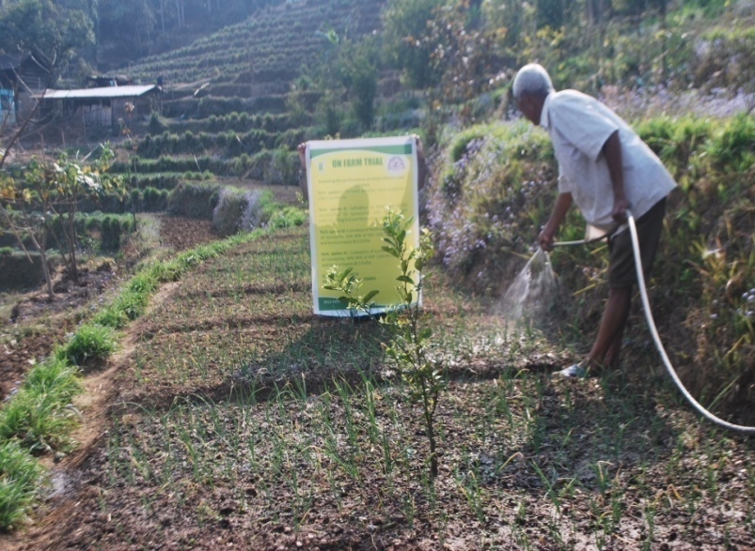
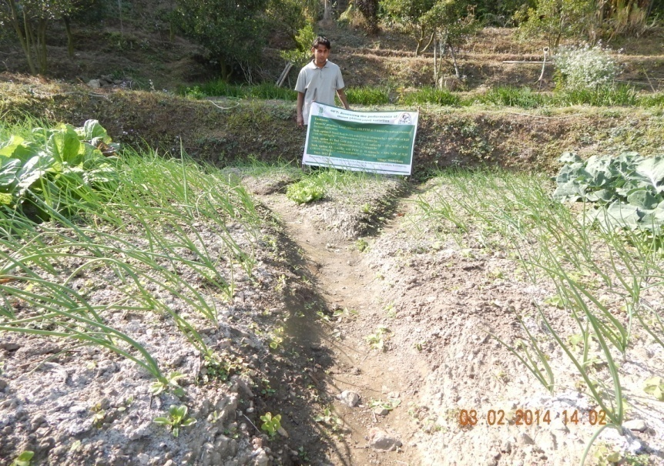

Thematic area: Vegetable based cropping systems
Problem definition: Poor bulb yield due to repeated use of same local cultivar which causes low bulb yield and occurrence of more disease and pest infestation.
Technology assessed: Assessing the performance of onion (Allium cepa) varieties
Table 2: Data on parameter in relation to Technology demonstrated (OFT 4)
Technology option | No. of trials | Yield component |  |  | Disease/ insect pest incidence (%) | Yield  (q/ha) | Cost of cultivation  (Rs./ha) | Gross return (Rs/ha) | Net return  (Rs./ha) | B:C ratio
Technology option | No. of trials | No. of effective tillers/hill | No. of spikelet per panicle | Test wt. (100 grain wt.)
Farmers’ practice: Local cultivar | 6 | - | - | - | - | 72.9 | 31870 | 58320 | 26450 | 1:1.83
Tech. option I: Nasik Red (N-53) | 6 | - | - | - | - | 113.8 | 49005 | 102420 | 53415 | 1:2.09
Tech. option II: Red Gold | 6 | - | - | - | - | 184.0 | 56136 | 165600 | 109464 | 1:2.98
Tech. option III: Luciffer | 6 | - | - | - | - | 157.6 | 55796 | 142840 | 87044 | 1:2.56

Results:
Based on the bulb yield and benefit: cost ratio, the Technology option II i.e. Red Gold variety with FYM @ 10 tonnes/ha, 50% NPK of RDF (100:50:100 kg/ha) and vermicompost @ 2.5 t/hawas found to be best against all other remaining technologies followed by Technology option IV. The Technology option II i.e. Red Gold variety with FYM @ 10 tonnes/ha, 50% NPK of RDF (100:50:100 kg/ha) and vermicompost @ 2.5 t/ha was recommended for higher bulb yield and profit of farmers.

OFT-5: Low production of large cardamom

1. | Title of On farm Trial | Low production of large cardamom
2. | Problem diagnose | Incidence of leaf blight disease
3. | Details of technologies selected for assessment/refinement | Farmers’ practice (No use of plant protection chemicals)  Tech. Option I: foliar application of COC @ 2.5 g/lit water  Tech. Option II: foliar application of COC @ 2.5 g/lit water + soil application of Trichoderma harzianum  Tech. Option III: foliar application of COC @ 2.5 g/lit water + soil drenching with COC @ 0.3%.
4. | Source of Technology | Spices Bord, Govt. of India
5. | Production system and thematic area | Irrigated ( sprinkle)
6. | Performance of the Technology with performance indicators | All the technical options (Three) proved effective as compared to farmers’ practice based on the capsule yield and benefit: cost ratio. However, the Technology option III, i.e. foliar application of COC @ 2.5 g/lit water + soil drenching with COC @ 0.3% found to be best.
7. | Final recommendation for micro level situation | The foliar application of COC @ 2.5 g/lit water during March- April followed by soil drenching with COC @ 0.3% can be recommended for disease management blight and yield as well.
8. | Constraints identified and feedback for research | Transportation, the farm where OFT was conducted is located in remote villages of hills.
9. | Process of farmers participation and their reaction | They participated actively through phone calls, personal contacts, field days, etc. They were satisfied and impressed about the best technology demonstrated through their participation during the whole trial period and expressed their views for further research and training programmes.

Thematic area: plant protection
Problem definition: Low production of large cardamom
Technology assessed: Assessment on leaf blight management of Large cardamom
Table 1: Data on parameter in relation to Technology demonstrated
Technology option | No. of trials | Yield component |  |  | Disease/ insect pest incidence (%) | Yield  (kg/ha) | Cost of cultivation  (Rs./ha) | Gross return (Rs/ha) | Net return  (Rs./ha) | BC ratio
Technology option | No. of trials | No. of effective tillers/hill | No. of spikelet per panicle | Test wt. (100 capsule wt.)
Farmers’ practice | 7 | 14 |  | 42g | 34.4 % | 253.7 | 35000 | 253700 | 218,000 | 1:7.23
Tech. Option I | 7 | 18 |  | 46 | 5.2% | 391.4 | 46000 | 391400 | 345,400 | 1:8.51
Tech. Option II: | 7 | 16 |  | 49 | 5.5% | 386.3 | 54,000 | 386300 | 332,300 | 1:7.15
Tech. Option III | 7 | 19 |  | 51 | 0 % | 410.6 | 53,000 | 410600 | 357,600 | 1:7.75
Results: All the technical options found to be effective.However, the Technology option III, i.e. foliar application of COC @ 2.5 g/lit water followed by soil drenching with COC @ 0.3% found to be best for management of leaf blight management of Large cardamom.
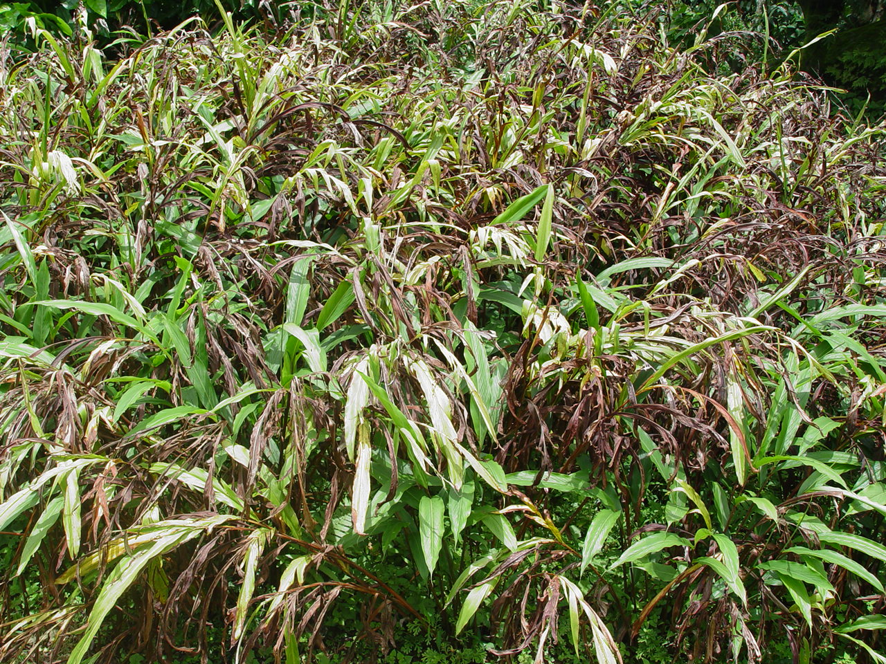
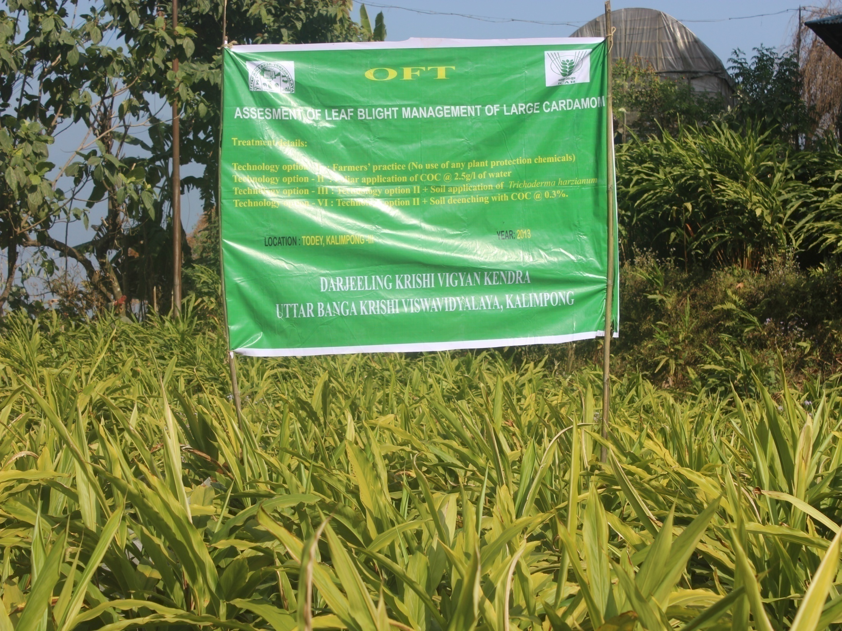
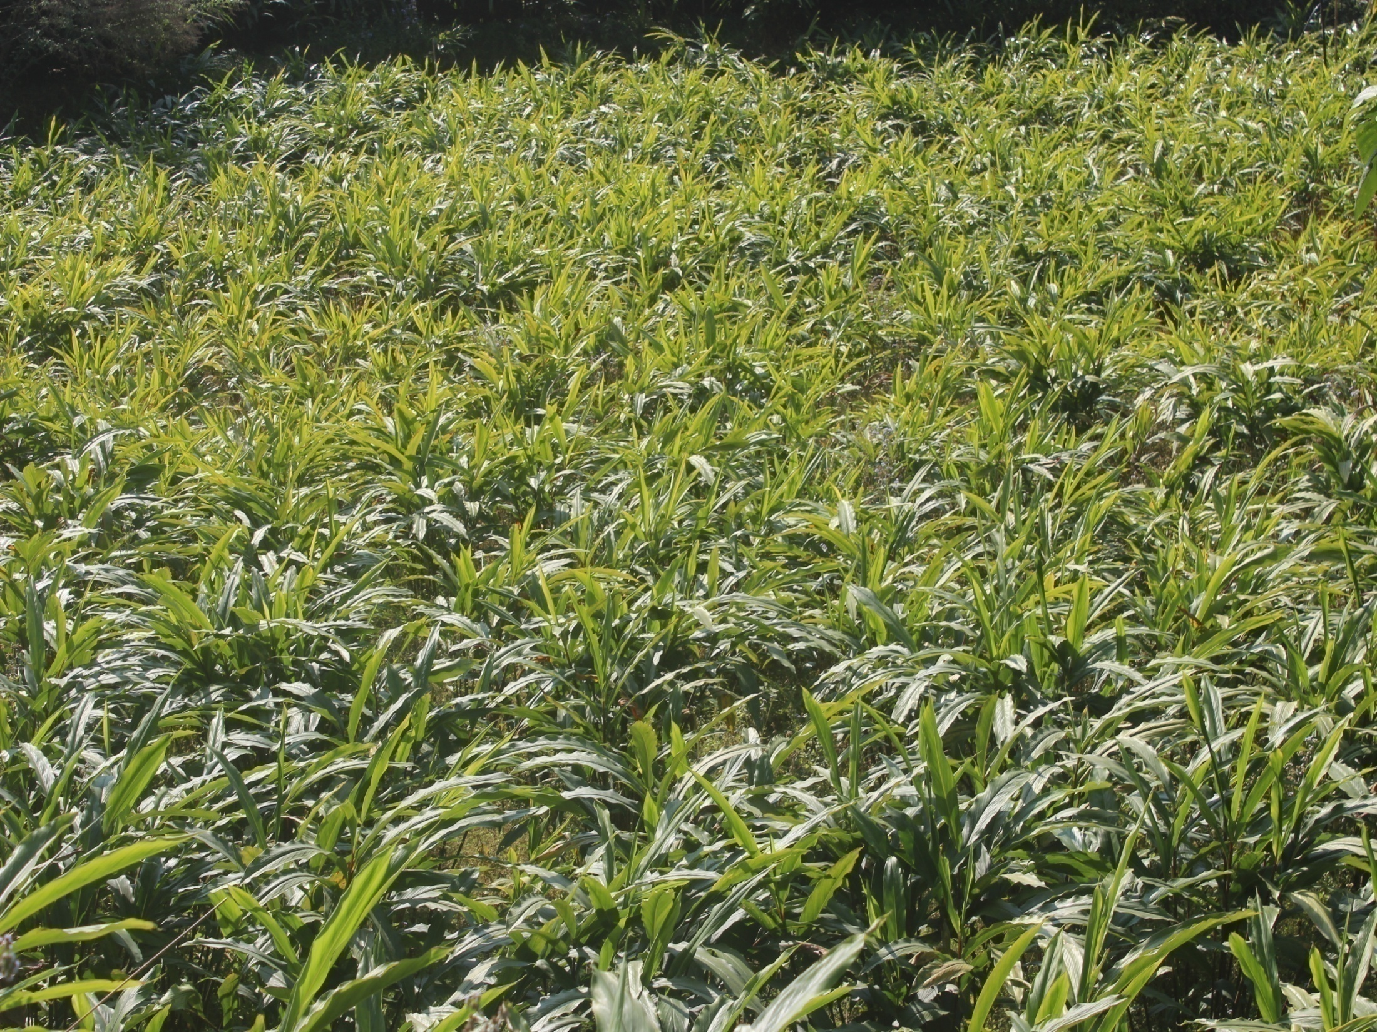

3.2 Achievements of Frontline Demonstrations

A. Details of FLDs implemented during 2013-14

Sl.  No. | Crop | Thematic area | Technology Demonstrated with detailed treatments | Area (ha) |  | No. of farmers/  demonstration |  |  | Reasons for shortfall in achievement
 |  |  |  | Proposed | Actual | SC/ST | Others | Total
1. | Large cardamom (Bharlangey) | Poor production of large cardamom | Soil amendment using  1. Commercial formulation  2. Soil amendment with dolomite/agri lime | 0.14 | 0.14 | 4 | 2 | 6 | --
2. | Garden Pea | Crop Production | High yielding variety – Azad Kranti | 1.00 | 1.00 | 3 | 3 | 6 | --
3. | Tomato | Crop protection | Use of bio- primed seedlings for crop management in Tomato | 1.00 | 1.00 | 4 | 2 | 6

Details of farming situation

Crop | Season | Farming situation (RF/Irrigated) | Soil type | Status of soil  (Kg/ha) |  |  | Previous crop | Sowing date | Harvest date | Seasonal rainfall (mm) | No. of rainy days
 |  |  |  | N | P₂O₅ | K₂O
Large cardamom (Bharlangey) | April - September | Rain fed | Brown forest Soil | 241 | 41 | 321 | Large Cardamom | Perennial crop | Nov – Dec 2013 | 1823.8
Garden Pea | Sept –  January | Rain fed | Acidic loamy |  |  |  | Rice | 04/09/2013 | Dec 13-January 14 | 150.5

In both the Tables, information of same crop should be provided. For example, if in Table 3.2A crops are mentioned as a,b,c,d etc., in the table for Details of farming situation, the same crop should be mentioned in the identical sequence.

Action photographs of Front Line Demonstrations

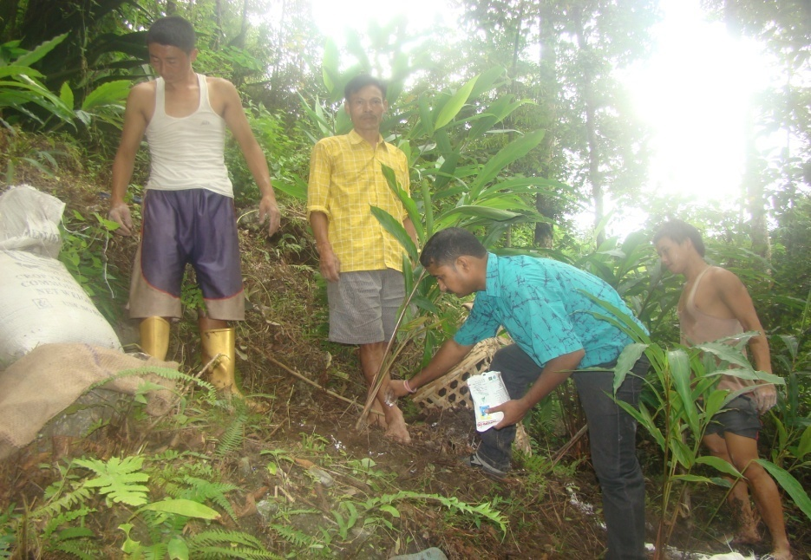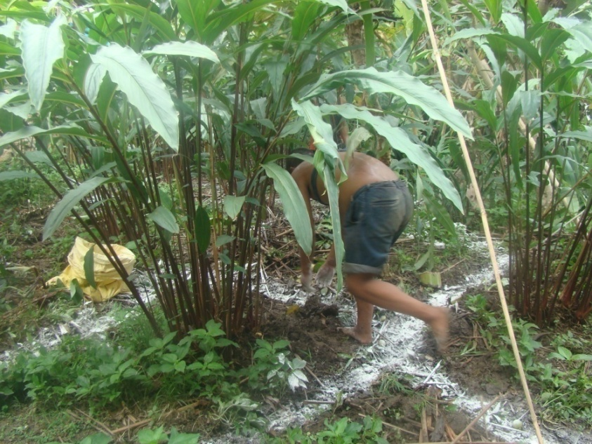
Application of Boron Limning

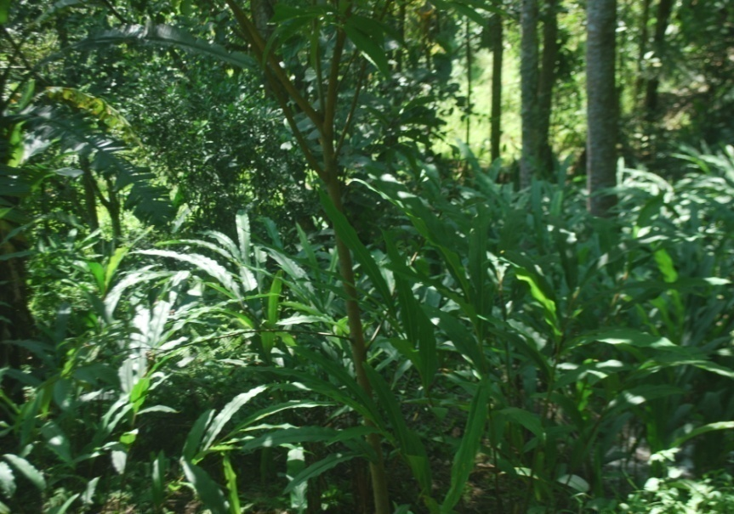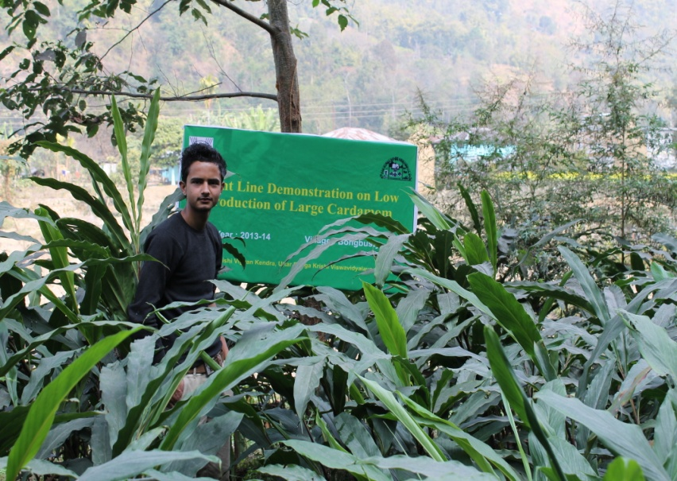

Healthy field Application of Vermi Compost

Action photographs of Front Line Demonstrations

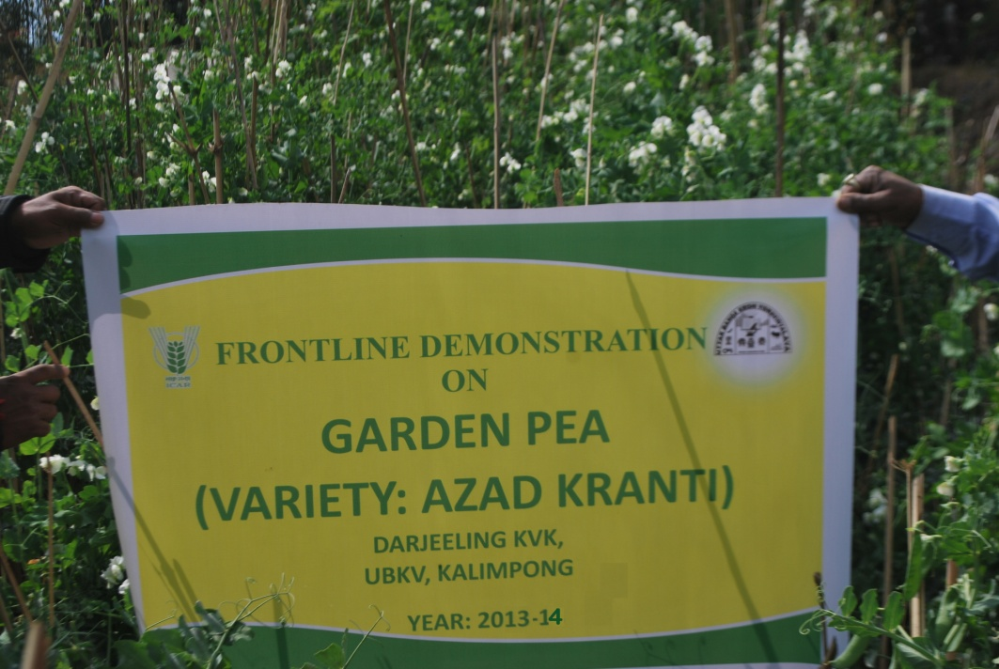
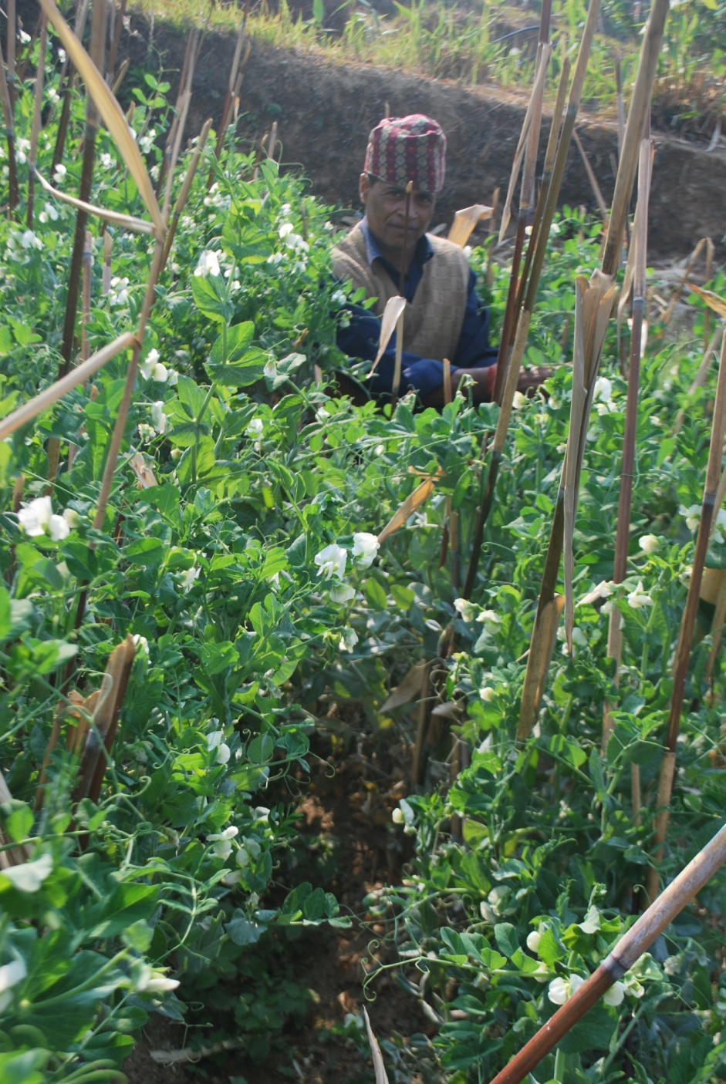

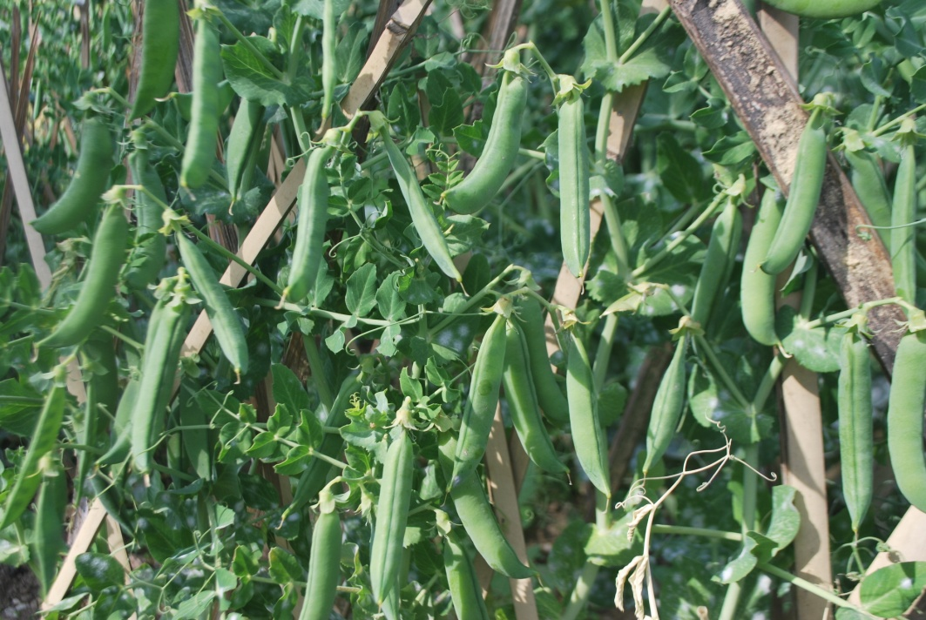

Performance of FLD

Oilseeds:

Frontline demonstrations on oilseed crops

Crop | Thematic Area | Name of the technology demonstrated | No. of Farmers | Area  (ha) | Yield (q/ha) |  | % Increase | *Economics of demonstration (Rs./ha) |  |  |  | *Economics of check  (Rs./ha)
 |  |  |  |  | Demo | Check | % Increase | Gross  Cost | Gross  Return | Net Return | **  BCR | Gross  Cost | Gross  Return | Net Return | **  BCR
Total

* Economics to be worked out based on total cost of production per unit area and not on critical inputs alone.
** BCR= GROSS RETURN/GROSS COST

Pulses
Frontline demonstration on pulse crops
Crop | Thematic Area | Name of the technology demonstrated | No. of Farmers | Area  (ha) | Yield (q/ha) |  | % Increase | *Economics of demonstration (Rs./ha) |  |  |  | *Economics of check  (Rs./ha)
 |  |  |  |  | Demo | Check | % Increase | Gross  Cost | Gross  Return | Net Return | **  BCR | Gross  Cost | Gross  Return | Net Return | **  BCR
 | Total

* Economics to be worked out based on total cost of production per unit area and not on critical inputs alone.
** BCR= GROSS RETURN/GROSS COST

Other crops
Crop | Thematic area | Name of the technology demonstrated | No. of Farmer | Area  (ha) | Yield (q/ha) |  | % change in yield | Other parameters |  | *Economics of demonstration (Rs./ha) |  |  |  | *Economics of check  (Rs./ha)
 |  |  |  |  | Demons  ration | Check | % change in yield | Demo | Check | Gross  Cost | Gross  Return | Net Return | **  BCR | Gross  Cost | Gross  Return | Net Return | **  BCR
Large cardamom (Bharlangey) | Poor production of large cardamom | Soil amendment using  1. Commercial formulation  2. Soil amendment with dolomite/agri lime | 6 | 0.14 | 2.76 | 2.40 | 15 |  |  | 57850 | 218592 | 160742 | 1:3.78 | 55972 | 178800 | 122828 | 1:3.19
Garden Pea | Crop Production | High yielding variety – Azad Kranti | 6 | 1.0 | 42.5 | 33.7 | 20.7 |  |  | 62256 | 158130 | 95874 | 1:.2.54 | 61755 | 125364 | 63609 | 1:2.03
Tomato | Crop protection | Use of bio- primed seedlings for crop management in Tomato | 6 | 1.0 | 220 | 195 | 12.8 |  |  | 78,853 | 220000 | 141147 | 1: 2.79 | 75,335 | 185250 | 109915 | 1:2.4
 | Total

Nutrient content | Initial soil test result | After harvesting
OC (%) | 1.4 | 1.67
pH | 4.5 | 5.52
Available N Kg ha⁻¹ | 230 | 245
Available P₂O₅Kg ha⁻¹ | 40 | 62
Available K₂OKg ha⁻¹ | 227 | 245

Livestock
Category | Thematic  area | Name of the technology demonstrated | No. of Farmer | No. of units | Major parameters |  | % change in major parameter | Other parameter |  | *Economics of demonstration (Rs.) |  |  |  | *Economics of check  (Rs.)
 |  |  |  |  | Demons  ration | Check | % change in major parameter | Demons  ration | Check | Gross  Cost | Gross  Return | Net Return | **  BCR | Gross  Cost | Gross  Return | Net Return | **  BCR
Dairy
Cow
Buffalo
Poultry
Rabbitry
Pigerry |  | Production performance of Ghunghroo pig under backyard farming system | 15 | 15 | Weight gain | Weight gain | 29.62 | Litter size | Litter size | 3760 | 9890 | 6130 | 2.63:1 | 3540 | 7630 | 4030 | 2.16:1
Sheep and goat
Duckery
Others (pl.specify)
Total

* Economics to be worked out based on total cost of production per unit area and not on critical inputs alone.
** BCR= GROSS RETURN/GROSS COST

Fisheries
Category | Thematic area | Name of the technology demonstrated | No. of Farmer | No.of units | Major parameters |  | % change in major parameter | Other parameter |  | *Economics of demonstration (Rs.) |  |  |  | *Economics of check  (Rs.)
 |  |  |  |  | Demons  ration | Check | % change in major parameter | Demons  ration | Check | Gross  Cost | Gross  Return | Net Return | **  BCR | Gross  Cost | Gross  Return | Net Return | **  BCR
Common carps
Mussels
Ornamental fishes
Others (pl.specify)
 | Total

* Economics to be worked out based on total cost of production per unit area and not on critical inputs alone.
** BCR= GROSS RETURN/GROSS COST
Other enterprises
Category | Name of the technology demonstrated | No. of Farmer | No.of units | Major parameters |  | % change in major parameter | Other parameter |  | *Economics of demonstration (Rs.) or Rs./unit |  |  |  | *Economics of check  (Rs.) or Rs./unit
 |  |  |  | Demons  ration | Check | % change in major parameter | Demons  ration | Check | Gross  Cost | Gross  Return | Net Return | **  BCR | Gross  Cost | Gross  Return | Net Return | **  BCR
Oyster mushroom | Enterprise development
Button mushroom
Vermicompost
Sericulture
Apiculture
Others (pl.specify)
Total

* Economics to be worked out based on total cost of production per unit area and not on critical inputs alone.
** BCR= GROSS RETURN/GROSS COST
Women empowerment
Category | Name of technology | No. of demonstrations | Name of observations | Demonstration | Check
Farm Women
Pregnant women
Adolescent Girl
Other women
Children
Neonatal
Infants
Farm implements and machinery
Name of the implement | Crop | Name of the technology demonstrated | No. of Farmer | Area (ha) | Filed observation (output/man hour) |  | % change in major parameter | Labor reduction (man days) |  |  |  | Cost reduction (Rs./ha or Rs./Unit)
 |  |  |  |  | Demons  ration | Check | % change in major parameter
* Economics to be worked out based on total cost of production per unit area and not on critical inputs alone.
** BCR= GROSS RETURN/GROSS COST

Demonstration details on crop hybrids
Crop | Name of the Hybrid | No. of  farmers | Area  (ha) | Yield (kg/ha) / major parameter |  |  | Economics (Rs./ha)
Cereals |  |  |  | Demo | Local check | % change | Gross  Cost | Gross  Return | Net  Return | BCR
Bajra
Maize | D 1588 | 72 | 10 | Continue
Paddy
Sorghum
Wheat
Others (pl.specify)

Total
Oilseeds
Castor
Mustard
Safflower
Sesame
Sunflower
Groundnut
Soybean
Others (pl.specify)
Total
Pulses
Greengram
Blackgram
Bengalgram
Redgram
Others (pl.specify)

Total
Vegetable crops
Bottle gourd
Capsicum
Cucumber
Tomato
Brinjal
Okra
Onion
Potato
Field bean
Others (pl.specify)

Total
Commercial crops
Cotton
Coconut
Others (pl.specify)

Total
Fodder crops
Napier (Fodder)
Maize (Fodder)
Sorghum (Fodder)
Others (pl.specify)

Total

Technical Feedback on the demonstrated technologies

S. No | Crop | Feed Back
1.

Extension and Training activities under FLD

SL.No. | Activity | Date | No. of activities organized | Number of participants | Remarks
1. | Field days | 30/09/2013 | 1 | 64
2. | Farmers Training | 20/02/2014  02/03/2014  08/03/2014 | 3 | 18  84  111
3. | Media coverage | NIL
4. | Training for extension functionaries | NIL

  - Achievements on Training (Including the sponsored and FLD training programmes):

Farmers and farm women (on campus)

Thematic Area | No. of Courses | No. of Participants |  |  |  |  |  |  |  |  |  | Grand Total
Thematic Area | No. of Courses | Other |  |  | SC |  |  |  | ST
 | No. of Courses | M | F | T | M | F |  | T | M | F | T | M | F | T
I. Crop Production
Weed Management
Resource Conservation Technologies
Cropping Systems
Crop Diversification
Integrated Farming
Water management
Seed production
Nursery management
Integrated Crop Management
Fodder production
Production of organic inputs
Others, (cultivation of crops )
II. Horticulture
a) Vegetable Crops
Integrated nutrient management
Water management | 1 | 13 | 6 | 19 | 1 | 0 |  | 1 | 6 | 1 | 7 | 20 | 7 | 27
Enterprise development
Skill development
Yield increment
Production of low volume and high value crops
Off-season vegetables | 2 | 25 | 13 | 38 | 0 | 0 |  | 0 | 4 | 1 | 5 | 29 | 14 | 43
Nursery raising
Export potential vegetables
Grading and standardization
Protective cultivation (Green Houses, Shade Net etc.)
Others, if any (Cultivation of Vegetable) | 1 | 12 | 3 | 15 | 0 | 0 |  | 0 | 2 | 0 | 2 | 14 | 3 | 17
Training and Pruning
b) Fruits
Layout and Management of Orchards
Cultivation of Fruit
Management of young plants/orchards
Rejuvenation of old orchards
Export potential fruits
Micro irrigation systems of orchards
Plant propagation techniques
Others, if any(INM)
c) Ornamental Plants
Nursery Management
Management of potted plants
Export potential of ornamental plants
Propagation techniques of Ornamental Plants
Others, if any
d) Plantation crops
Production and Management technology
Processing and value addition
Others, if any
e) Tuber crops
Production and Management technology
Processing and value addition
Others, if any
f) Spices
Production and Management technology | 2 | 29 | 17 | 46 | 0 | 0 |  | 0 | 3 | 0 | 3 | 32 | 17 | 49
Processing and value addition
Others, if any
g) Medicinal and Aromatic Plants
Nursery management
Production and management technology
Post harvest technology and value addition
Others, if any
III. Soil Health and Fertility Management
Soil fertility management
Soil and Water Conservation
Integrated Nutrient Management
Production and use of organic inputs
Management of Problematic soils | 4 | 30 | 30 | 70 | 5 | 2 |  | 7 | 13 | 14 | 27 | 58 | 46 | 104
Micro nutrient deficiency in crops
Nutrient Use Efficiency
Soil and Water Testing
Others, if any
IV. Livestock Production and Management
Dairy Management
Poultry Management
Piggery Management
Rabbit Management
Disease Management
Feed management
Production of quality animal products
Others, if any Goat farming | 1 | 14 | 2 | 16 | 0 | 0 |  | 0 | 17 | 2 | 19 | 31 | 4 | 35
V. Home Science/Women empowerment
Household food security by kitchen gardening and nutrition gardening
Design and development of low/minimum cost diet
Designing and development for high nutrient efficiency diet
Minimization of nutrient loss in processing
Gender mainstreaming through SHGs
Storage loss minimization techniques
Enterprise development
Value addition
Income generation activities for empowerment of rural Women
Location specific drudgery reduction technologies
Rural Crafts
Capacity building
Women and child care
Others, if any
VI. Agril. Engineering
Installation and maintenance of micro irrigation systems
Use of Plastics in farming practices
Production of small tools and implements
Repair and maintenance of farm machinery and implements
Small scale processing and value addition
Post Harvest Technology
Others, if any
VII. Plant Protection
Integrated Pest Management | 2 | 22 | 4 | 26 | 0 | 0 |  | 0 | 16 | 1 | 17 | 38 | 5 | 43
Integrated Disease Management | 1 | 12 | 3 | 15 | 0 | 0 |  | 0 | 2 | 0 | 2 | 14 | 3 | 17
Bio-control of pests and diseases
Production of bio control agents and bio pesticides
Others, if any
VIII. Fisheries
Integrated fish farming
Carp breeding and hatchery management
Carp fry and fingerling rearing
Composite fish culture & fish disease
Fish feed preparation & its application to fish pond, like nursery, rearing & stocking pond
Hatchery management and culture of freshwater prawn
Breeding and culture of ornamental fishes
Portable plastic carp hatchery
Pen culture of fish and prawn
Shrimp farming
Edible oyster farming
Pearl culture
Fish processing and value addition
Others, if any
IX. Production of Inputs at site
Seed Production
Planting material production
Bio-agents production
Bio-pesticides production
Bio-fertilizer production
Vermi-compost production
Organic manures production
Production of fry and fingerlings
Production of Bee-colonies and wax sheets
Small tools and implements
Production of livestock feed and fodder
Production of Fish feed
Others, if any
X. Capacity Building and Group Dynamics
Leadership development
Group dynamics
Formation and Management of SHGs
Mobilization of social capital
Entrepreneurial development of farmers/youths
WTO and IPR issues
Others, if any
XI Agro-forestry
Production technologies
Nursery management
Integrated Farming Systems
XII. Others (Pl. Specify)
TOTAL | 14 | 157 | 78 | 245 | 6 |  | 2 | 8 | 63 | 19 | 82 | 236 | 99 | 335

Rural Youth (on campus)

Thematic Area | No. of Courses | No. of Participants |  |  |  |  |  |  |  |  |  | Grand Total
Thematic Area | No. of Courses | Other |  |  | SC |  |  |  | ST
 | No. of Courses | M | F | T | M | F |  | T | M | F | T | M | F | T
Mushroom Production | 2 | 15 | 4 | 19 | 5 |  | 4 | 9 | 42 | 5 | 47 | 62 | 13 | 75
Bee-keeping
Integrated farming
Seed production
Production of organic inputs
Integrated Farming
Planting material production
Vermi-culture
Sericulture
Protected cultivation of vegetable crops
Commercial fruit production | 1 | 4 | 3 | 7 | 0 |  | 0 | 0 | 3 | 25 | 28 | 7 | 28 | 35
Repair and maintenance of farm machinery and implements | 1 | 9 | 21 | 30 | 0 |  | 2 | 2 | 5 | 5 | 10 | 14 | 28 | 42
Nursery Management of Horticulture crops
Training and pruning of orchards
Value addition
Production of quality animal products
Dairying
Sheep and goat rearing | 1 | 1 | 16 | 17 | 0 |  | 1 | 1 | 0 | 13 | 13 | 1 | 31 | 32
Quail farming
Piggery
Rabbit farming
Poultry production
Ornamental fisheries
Enterprise development
Para vets
Para extension workers
Composite fish culture
Freshwater prawn culture
Shrimp farming
Pearl culture
Cold water fisheries
Fish harvest and processing technology
Fry and fingerling rearing
Small scale processing
Post Harvest Technology
Tailoring and Stitching
Rural Crafts
TOTAL | 5 | 29 | 44 | 73 | 5 |  | 7 | 12 | 50 | 48 | 98 | 84 | 100 | 184

Extension Personnel (on campus)

Thematic Area | No. of Courses | No. of Participants |  |  |  |  |  |  |  |  |  | Grand Total
Thematic Area | No. of Courses | Other |  |  | SC |  |  |  | ST
 | No. of Courses | M | F | T | M | F |  | T | M | F | T | M | F | T
Productivity enhancement in field crops
Value addition
Integrated Pest Management | 1 | 10 | 1 | 11 | 1 |  | 0 | 1 | 8 | 0 | 8 | 19 | 1 | 20
Integrated Nutrient management | 1 | 9 | 1 | 10 | 1 |  | 0 | 1 | 5 | 0 | 5 | 15 | 1 | 16
Rejuvenation of old orchards
Protected cultivation technology
Formation and Management of SHGs
Group Dynamics and farmers organization
Information networking among farmers
Capacity building for ICT application | 1 | 10 | 15 | 25 | 2 |  | 1 | 3 | 2 | 6 | 8 | 14 | 22 | 36
Care and maintenance of farm machinery and implements | 1 | 12 | 0 | 12 | 1 |  | 0 | 1 | 5 | 0 | 5 | 18 | 0 | 18
WTO and IPR issues
Management in farm animals
Livestock feed and fodder production
Household food security
Women and Child care
Low cost and nutrient efficient diet designing
Production and use of organic inputs
Gender mainstreaming through SHGs
TOTAL | 4 | 41 | 17 | 58 | 5 |  | 1 | 6 | 20 | 6 | 26 | 66 | 24 | 90

Farmers and farm women (off campus)

Thematic Area | No. of Courses | No. of Participants |  |  |  |  |  |  |  |  | Grand Total
Thematic Area | No. of Courses | Other |  |  | SC |  |  | ST
 | No. of Courses | M | F | T | M | F | T | M | F | T | M | F | T
I. Crop Production
Weed Management
Resource Conservation Technologies
Cropping Systems
Crop Diversification
Integrated Farming
Water management
Seed production
Nursery management
Integrated Crop Management | 3 | 14 | 27 | 41 | 0 | 0 | 0 | 141 | 124 | 265 | 155 | 151 | 306
Fodder production
Production of organic inputs
Others, (cultivation of crops )
II. Horticulture
a) Vegetable Crops
Integrated nutrient management
Water management
Enterprise development
Skill development
Yield increment
Production of low volume and high value crops
Off-season vegetables
Nursery raising
Export potential vegetables
Grading and standardization
Protective cultivation (Green Houses, Shade Net etc.)
Others, if any (Cultivation of Vegetable)
Training and Pruning
b) Fruits
Layout and Management of Orchards
Cultivation of Fruit
Management of young plants/orchards
Rejuvenation of old orchards
Export potential fruits
Micro irrigation systems of orchards
Plant propagation techniques
Others, if any(INM)
c) Ornamental Plants
Nursery Management
Management of potted plants
Export potential of ornamental plants
Propagation techniques of Ornamental Plants
Others, if any
d) Plantation crops
Production and Management technology
Processing and value addition
Others, if any
e) Tuber crops
Production and Management technology
Processing and value addition
Others, if any
f) Spices
Production and Management technology
Processing and value addition
Others, if any
g) Medicinal and Aromatic Plants
Nursery management
Production and management technology
Post harvest technology and value addition
Others, if any
III. Soil Health and Fertility Management
Soil fertility management
Soil and Water Conservation
Integrated Nutrient Management
Production and use of organic inputs
Management of Problematic soils
Micro nutrient deficiency in crops
Nutrient Use Efficiency
Soil and Water Testing | 2 | 76 | 12 | 88 | 3 | 1 | 4 | 1 | 0 | 1 | 80 | 13 | 93
Others, if any
IV. Livestock Production and Management
Dairy Management | 1 | 14 | 12 | 26 | 3 | 2 | 5 | 0 | 0 | 0 | 17 | 14 | 31
Poultry Management
Piggery Management
Rabbit Management
Disease Management
Feed management
Production of quality animal products
Others, if any Goat farming
V. Home Science/Women empowerment
Household food security by kitchen gardening and nutrition gardening
Design and development of low/minimum cost diet
Designing and development for high nutrient efficiency diet
Minimization of nutrient loss in processing
Gender mainstreaming through SHGs
Storage loss minimization techniques
Enterprise development
Value addition
Income generation activities for empowerment of rural Women
Location specific drudgery reduction technologies
Rural Crafts
Capacity building
Women and child care
Others, if any
VI. Agril. Engineering
Installation and maintenance of micro irrigation systems
Use of Plastics in farming practices
Production of small tools and implements
Repair and maintenance of farm machinery and implements
Small scale processing and value addition
Post Harvest Technology
Others, if any
VII. Plant Protection
Integrated Pest Management | 6 | 65 | 31 | 96 | 5 | 8 | 13 | 47 | 24 | 71 | 117 | 64 | 181
Integrated Disease Management | 9 | 157 | 32 | 189 | 29 | 1 | 30 | 98 | 77 | 175 | 284 | 110 | 394
Bio-control of pests and diseases
Production of bio control agents and bio pesticides
Others, if any
VIII. Fisheries
Integrated fish farming
Carp breeding and hatchery management
Carp fry and fingerling rearing
Composite fish culture & fish disease
Fish feed preparation & its application to fish pond, like nursery, rearing & stocking pond
Hatchery management and culture of freshwater prawn
Breeding and culture of ornamental fishes
Portable plastic carp hatchery
Pen culture of fish and prawn
Shrimp farming
Edible oyster farming
Pearl culture
Fish processing and value addition
Others, if any
IX. Production of Inputs at site
Seed Production
Planting material production
Bio-agents production
Bio-pesticides production
Bio-fertilizer production
Vermi-compost production
Organic manures production
Production of fry and fingerlings
Production of Bee-colonies and wax sheets
Small tools and implements
Production of livestock feed and fodder
Production of Fish feed
Others, if any
X. Capacity Building and Group Dynamics
Leadership development
Group dynamics
Formation and Management of SHGs
Mobilization of social capital
Entrepreneurial development of farmers/youths
WTO and IPR issues
Others, if any
XI Agro-forestry
Production technologies
Nursery management
Integrated Farming Systems
XII. Others (Pl. Specify)
TOTAL | 21 | 326 | 114 | 440 | 40 | 12 | 52 | 287 | 225 | 512 | 653 | 352 | 1005

RURAL YOUTH (Off Campus)
Thematic Area | No. of Courses | No. of Participants |  |  |  |  |  |  |  |  |  | Grand Total
Thematic Area | No. of Courses | Other |  |  | SC |  |  |  | ST
 | No. of Courses | M | F | T | M | F |  | T | M | F | T | M | F | T
Mushroom Production
Bee-keeping
Integrated farming
Seed production
Production of organic inputs
Integrated Farming
Planting material production
Vermi-culture
Sericulture
Protected cultivation of vegetable crops
Commercial fruit production
Repair and maintenance of farm machinery and implements
Nursery Management of Horticulture crops
Training and pruning of orchards
Value addition
Production of quality animal products
Dairying
Sheep and goat rearing
Quail farming
Piggery
Rabbit farming
Poultry production
Ornamental fisheries
Para vets
Para extension workers
Composite fish culture
Freshwater prawn culture
Shrimp farming
Pearl culture
Cold water fisheries
Fish harvest and processing technology
Fry and fingerling rearing
Small scale processing | 1 | 23 | 6 | 29 | 10 |  | 5 | 15 | 9 | 7 | 16 | 42 | 18 | 60
Post Harvest Technology
Tailoring and Stitching
Rural Crafts
ICT | 4 | 84 | 53 | 137 | 4 |  | 7 | 11 | 20 | 45 | 65 | 108 | 105 | 213
TOTAL | 5 | 107 | 59 | 166 | 14 |  | 12 | 26 | 29 | 52 | 81 | 150 | 123 | 273

Extension Personnel (Off Campus)
Thematic Area | No. of Courses | No. of Participants |  |  |  |  |  |  |  |  | Grand Total
Thematic Area | No. of Courses | Other |  |  | SC |  |  | ST
 | No. of Courses | M | F | T | M | F | T | M | F | T | M | F | T
Productivity enhancement in field crops
Integrated Pest Management
Integrated Nutrient management
Rejuvenation of old orchards
Protected cultivation technology
Formation and Management of SHGs
Group Dynamics and farmers organization
Information networking among farmers
Capacity building for ICT application
Care and maintenance of farm machinery and implements
WTO and IPR issues
Management in farm animals
Livestock feed and fodder production
Household food security
Women and Child care
Low cost and nutrient efficient diet designing
Production and use of organic inputs
Gender mainstreaming through SHGs
Crop intensification
TOTAL

Consolidated table (ON and OFF Campus)
Farmers & Farm Women
Thematic Area | No. of Courses | No. of Participants |  |  |  |  |  |  |  |  | Grand Total
Thematic Area | No. of Courses | Other |  |  | SC |  |  | ST
 | No. of Courses | M | F | T | M | F | T | M | F | T | M | F | T
I. Crop Production
Weed Management
Resource Conservation Technologies
Cropping Systems
Crop Diversification
Integrated Farming
Water management
Seed production
Nursery management
Integrated Crop Management | 3 | 14 | 27 | 41 | 0 | 0 | 0 | 141 | 124 | 265 | 155 | 151 | 306
Fodder production
Production of organic inputs
Others, (cultivation of crops )
II. Horticulture
a) Vegetable Crops
Integrated nutrient management
Water management | 1 | 13 | 6 | 19 | 1 | 0 | 1 | 6 | 1 | 7 | 20 | 7 | 27
Enterprise development
Skill development
Yield increment
Production of low volume and high value crops
Off-season vegetables | 2 | 25 | 13 | 38 | 0 | 0 | 0 | 4 | 1 | 5 | 29 | 14 | 43
Nursery raising
Export potential vegetables
Grading and standardization
Protective cultivation (Green Houses, Shade Net etc.)
Others, if any (Cultivation of Vegetable) | 1 | 12 | 3 | 15 | 0 | 0 | 0 | 2 | 0 | 2 | 14 | 3 | 17
Training and Pruning
b) Fruits
Layout and Management of Orchards
Cultivation of Fruit
Management of young plants/orchards
Rejuvenation of old orchards
Export potential fruits
Micro irrigation systems of orchards
Plant propagation techniques
Others, if any(INM)
c) Ornamental Plants
Nursery Management
Management of potted plants
Export potential of ornamental plants
Propagation techniques of Ornamental Plants
Others, if any
d) Plantation crops
Production and Management technology
Processing and value addition
Others, if any
e) Tuber crops
Production and Management technology
Processing and value addition
Others, if any
f) Spices
Production and Management technology | 2 | 29 | 17 | 46 | 0 | 0 | 0 | 3 | 0 | 3 | 32 | 17 | 49
Processing and value addition
Others, if any
g) Medicinal and Aromatic Plants
Nursery management
Production and management technology
Post harvest technology and value addition
Others, if any
III. Soil Health and Fertility Management
Soil fertility management
Soil and Water Conservation
Integrated Nutrient Management
Production and use of organic inputs
Management of Problematic soils | 4 | 30 | 30 | 70 | 5 | 2 | 7 | 13 | 14 | 27 | 58 | 46 | 104
Micro nutrient deficiency in crops
Nutrient Use Efficiency
Soil and Water Testing | 2 | 76 | 12 | 88 | 3 | 1 | 4 | 1 | 0 | 1 | 80 | 13 | 93
Others, if any
IV. Livestock Production and Management
Dairy Management | 1 | 14 | 12 | 26 | 3 | 2 | 5 | 0 | 0 | 0 | 17 | 14 | 31
Poultry Management
Piggery Management
Rabbit Management
Disease Management
Feed management
Production of quality animal products
Others, if any Goat farming | 1 | 14 | 2 | 16 | 0 | 0 | 0 | 17 | 2 | 19 | 31 | 4 | 35
V. Home Science/Women empowerment
Household food security by kitchen gardening and nutrition gardening
Design and development of low/minimum cost diet
Designing and development for high nutrient efficiency diet
Minimization of nutrient loss in processing
Gender mainstreaming through SHGs
Storage loss minimization techniques
Enterprise development
Value addition
Income generation activities for empowerment of rural Women
Location specific drudgery reduction technologies
Rural Crafts
Capacity building
Women and child care
Others, if any
VI. Agril. Engineering
Installation and maintenance of micro irrigation systems
Use of Plastics in farming practices
Production of small tools and implements
Repair and maintenance of farm machinery and implements
Small scale processing and value addition
Post Harvest Technology
Others, if any
VII. Plant Protection
Integrated Pest Management | 8 | 87 | 35 | 122 | 5 | 8 | 13 | 63 | 25 | 88 | 155 | 69 | 224
Integrated Disease Management | 10 | 169 | 35 | 204 | 29 | 1 | 30 | 100 | 77 | 177 | 298 | 113 | 411
Bio-control of pests and diseases
Production of bio control agents and bio pesticides
Others, if any
VIII. Fisheries
Integrated fish farming
Carp breeding and hatchery management
Carp fry and fingerling rearing
Composite fish culture & fish disease
Fish feed preparation & its application to fish pond, like nursery, rearing & stocking pond
Hatchery management and culture of freshwater prawn
Breeding and culture of ornamental fishes
Portable plastic carp hatchery
Pen culture of fish and prawn
Shrimp farming
Edible oyster farming
Pearl culture
Fish processing and value addition
Others, if any
IX. Production of Inputs at site
Seed Production
Planting material production
Bio-agents production
Bio-pesticides production
Bio-fertilizer production
Vermi-compost production
Organic manures production
Production of fry and fingerlings
Production of Bee-colonies and wax sheets
Small tools and implements
Production of livestock feed and fodder
Production of Fish feed
Others, if any
X. Capacity Building and Group Dynamics
Leadership development
Group dynamics
Formation and Management of SHGs
Mobilization of social capital
Entrepreneurial development of farmers/youths
WTO and IPR issues
Others, if any
XI Agro-forestry
Production technologies
Nursery management
Integrated Farming Systems
XII. Others (Pl. Specify)
TOTAL | 35 | 483 | 192 | 685 | 46 | 14 | 60 | 350 | 244 | 594 | 889 | 451 | 1340

RURAL YOUTH (On and Off Campus)
Thematic Area | No. of Courses | No. of Participants |  |  |  |  |  |  |  |  |  | Grand Total
Thematic Area | No. of Courses | Other |  |  | SC |  |  |  | ST
 | No. of Courses | M | F | T | M | F |  | T | M | F | T | M | F | T
Mushroom Production | 2 | 15 | 4 | 19 | 5 |  | 4 | 9 | 42 | 5 | 47 | 62 | 13 | 75
Bee-keeping
Integrated farming
Seed production
Production of organic inputs
Integrated Farming
Planting material production
Vermi-culture
Sericulture
Protected cultivation of vegetable crops
Commercial fruit production | 1 | 4 | 3 | 7 | 0 |  | 0 | 0 | 3 | 25 | 28 | 7 | 28 | 35
Repair and maintenance of farm machinery and implements | 1 | 9 | 21 | 30 | 0 |  | 2 | 2 | 5 | 5 | 10 | 14 | 28 | 42
Nursery Management of Horticulture crops
Training and pruning of orchards
Value addition
Production of quality animal products
Dairying
Sheep and goat rearing | 1 | 1 | 16 | 17 | 0 |  | 1 | 1 | 0 | 13 | 13 | 1 | 31 | 32
Quail farming
Piggery
Rabbit farming
Poultry production
Ornamental fisheries
Para vets
Para extension workers
Composite fish culture
Freshwater prawn culture
Shrimp farming
Pearl culture
Cold water fisheries
Fish harvest and processing technology
Fry and fingerling rearing
Small scale processing | 1 | 23 | 6 | 29 | 10 |  | 5 | 15 | 9 | 7 | 16 | 42 | 18 | 60
Post Harvest Technology
Tailoring and Stitching
Rural Crafts
ICT | 4 | 84 | 53 | 137 | 4 |  | 7 | 11 | 20 | 45 | 65 | 108 | 105 | 213
TOTAL | 10 | 136 | 103 | 239 | 19 |  | 19 | 38 | 79 | 100 | 179 | 234 | 223 | 457

Extension Personnel (On and Off Campus)

Thematic Area | No. of Courses | No. of Participants |  |  |  |  |  |  |  |  | Grand Total
Thematic Area | No. of Courses | Other |  |  | SC |  |  | ST
 | No. of Courses | M | F | T | M | F | T | M | F | T | M | F | T
Productivity enhancement in field crops
Integrated Pest Management
Integrated Nutrient management | 1 | 10 | 1 | 11 | 1 | 0 | 1 | 8 | 0 | 8 | 19 | 1 | 20
Rejuvenation of old orchards | 1 | 9 | 1 | 10 | 1 | 0 | 1 | 5 | 0 | 5 | 15 | 1 | 16
Protected cultivation technology
Formation and Management of SHGs
Group Dynamics and farmers organization
Information networking among farmers
Capacity building for ICT application
Care and maintenance of farm machinery and implements | 1 | 10 | 15 | 25 | 2 | 1 | 3 | 2 | 6 | 8 | 14 | 22 | 36
WTO and IPR issues | 1 | 12 | 0 | 12 | 1 | 0 | 1 | 5 | 0 | 5 | 18 | 0 | 18
Management in farm animals
Livestock feed and fodder production
Household food security
Women and Child care
Low cost and nutrient efficient diet designing
Production and use of organic inputs
Gender mainstreaming through SHGs
Crop intensification
TOTAL | 4 | 41 | 17 | 58 | 5 | 1 | 6 | 20 | 6 | 26 | 66 | 24 | 90

Please furnish the details of training programmes as Annexure in the proforma given below
Date | Clientele |  | Title of the training programme | Duration in days | Venue (Off / On Campus) | Number of participants |  |  | Number of SC/ST
 |  |  |  |  |  | Male | Female | Total | Male | Female | Total
Agronomy | EF | Mechanized farming in hill agriculture |  | 1 | ON | 18 | 0 | 18 | 5 | 0 | 5
 | PF | Package and practices of Maize |  | 2 | OFF | 97 | 98 | 195 | 90 | 81 | 171
Fishery
Home Science
Horticulture | RY | Cultivation of Oyster Mushroom |  | 1 | OFF | 62 | 13 | 75 | 47 | 9 | 56
 | PF | Micro irrigation & polyhouse cultivation |  | 1 | ON | 20 | 7 | 27 | 6 | 1 | 7
 | RY | Prospects of horticulture in Darjeeling Hill |  | 1 | ON | 7 | 28 | 35 | 3 | 25 | 28
 | RY | Training on mushroom and food preservation |  | 14 | ON | 6 | 28 | 34 | 1 | 5 | 6
 | PF | Cultivation of large cardamom |  | 1 | ON | 17 | 14 | 31 | 0 | 0 | 0
 | PF | Cultivation of off season vegetables |  | 1 | ON | 14 | 2 | 16 | 2 | 0 | 2
 | PF | Cultivation of Large cardamom |  | 1 | ON | 15 | 3 | 18 | 3 | 0 | 3
 | PF | Cultivation of off season vegetables |  | 1 | ON | 15 | 12 | 27 | 2 | 1 | 3
Plant Protection | PF | Training on management of Citrus diseases |  | 1 | OFF | 18 | 2 | 20 | 6 | 1 | 7
 | PF | Training on management of vegetable diseases |  | 1 | OFF | 25 | 4 | 29 | 7 | 1 | 8
 | PF | Pest and diseases management in citrus |  | 1 | OFF | 38 | 37 | 75 | 38 | 37 | 75
 | PF | IPM on Rice |  | 1 | OFF | 24 | 1 | 25 | 0 | 0 | 0
 | PF | Management of ginger diseases |  | 1 | OFF | 22 | 11 | 33 | 14 | 11 | 25
 | PF | Management of insect pest and diseases of round chilli and other solanaceous vegetables. |  | 1 | OFF | 19 | 5 | 24 | 15 | 3 | 18
 | PF | Training on Rhizome rot complex disease of ginger |  | 1 | OFF | 19 | 8 | 27 | 2 | 1 | 3
 | PF | Prevention of late blight of potato and other solanacious vegetables |  | 1 | OFF | 32 | 3 | 35 | 6 | 0 | 6
 | PF | Rodent management in rice field |  | 1 | OFF | 9 | 10 | 19 | 1 | 2 | 3
 | PF | Management of pest and diseases of Rice |  | 1 | OFF | 64 | 0 | 64 | 25 | 0 | 25
 | PF | IPM on winter vegetables |  | 2 | OFF | 55 | 55 | 110 | 39 | 49 | 88
 | EF | Integrated pest management |  | 1 | ON | 19 | 1 | 20 | 9 | 0 | 9
 | PF | IPM on Potato |  | 1 | OFF | 13 | 12 | 25 | 7 | 2 | 9
 | PF | Diseases management on potato |  | 1 | OFF | 50 | 21 | 71 | 14 | 2 | 16
 | PF | IPM on Citrus and Vegetables |  | 1 | OFF | 13 | 4 | 17 | 6 | 0 | 6
 | PF | IPM on vegetables |  | 1 | ON | 14 | 3 | 17 | 2 | 0 | 2
 | PF | Management of pest and diseases of Large cardamom and ginger |  | 1 | ON | 14 | 3 | 17 | 2 | 0 | 2
 | PF | Disease pest management of vegetables |  | 1 | ON | 24 | 2 | 26 | 14 | 1 | 15
Animal Husbandry | RY | Demonstration on castration of animals |  | 1 | ON | 31 | 1 | 32 | 14 | 0 | 14
 | PF | Healthcare and management of dairy animals |  | 1 | OFF | 17 | 14 | 31 | 3 | 2 | 5
 | PF | Scientific goatery management in hill |  | 1 | ON | 31 | 4 | 35 | 17 | 2 | 19
 | PF | Scientific Poultry farming practices
Agriculture Extension | RY | Role of ICT in agriculture |  | 1 | OFF | 26 | 7 | 33 | 6 | 1 | 7
 | RY | Role of ICT in agriculture |  | 1 | OFF | 17 | 56 | 73 | 14 | 46 | 60
 | RY | Capacity building on maintenance of farm equipments |  | 1 | OFF | 14 | 28 | 42 | 5 | 7 | 12
 | RY | Role of ICT in agriculture |  | 1 | OFF | 25 | 38 | 63 | 2 | 5 | 7
 | RY | Capacity building prospective and issues |  | 1 | ON | 14 | 22 | 36 | 4 | 7 | 11
 | RY | Handling of farmers’ friendly software citrus e clinic |  | 1 | OFF | 40 | 4 | 44 | 2 | 0 | 2
 | RY | Prospects of SHG |  | 1 | OFF | 42 | 18 | 60 | 19 | 12 | 31
 | PF | Training of Headmasters of farm school |  | 6 | ON | 84 | 18 | 102 | 12 | 0 | 12
Soil Science | PF | Soil testing and fertilizer recommendation |  | 1 | OFF | 61 | 5 | 66 | 0 | 0 | 0
 | RY | Soil testing and fertilizer recommendation |  | 1 | ON | 15 | 22 | 37 | 4 | 9 | 13
 | RY | Soil testing and fertilizer recommendation |  | 1 | ON | 11 | 8 | 19 | 2 | 2 | 4
 | EF | Integrated nutrient management |  | 1 | ON | 15 | 1 | 16 | 6 | 0 | 6
 | PF | Soil testing and fertilizer recommendation |  | 1 | OFF | 19 | 8 | 27 | 4 | 1 | 5
 | PF | Importance soil testing, method of soil sample collection & its analysis |  | 1 | ON | 21 | 8 | 29 | 10 | 5 | 15
 | PF | Importance soil testing, method of soil sample collection & its analysis |  | 1 | ON | 14 | 3 | 17 | 2 | 0 | 2

(D) Vocational training programmes for Rural Youth

Vocational training programmes for Rural Youth
Crop / Enterprise | Identified Thrust Area | Training title* | Duration (days) | No. of Participants |  |  | Self employed after training |  |  | Number of persons employed else where
 |  |  |  | Male | Female | Total | Type of units | Number  of units | Number of persons employed
Horticulture |  | Training on Mushroom cultivation & food preservation | 7 | 3 | 15 | 18 | Production | 4 | 0
 |  | Training on Mushroom cultivation & food preservation | 5 | 3 | 13 | 16 | Production | 3 | 0
 |  | Maintenance of farm equipments | 1 | 14 | 28 | 42 | Service centre | 2 | 0
*training title should specify the major technology /skill transferred
(E) Sponsored Training Programmes
Sl.No | Title | Thematic area | Month | Duration (days) | Client | No. of courses | No. of Participants |  |  |  |  |  |  |  |  |  | Sponsoring Agency
Sl.No | Title | Thematic area |  |  | PF/RY/EF | No. of courses | Male |  |  | Female |  |  | Total |  |  |  | Sponsoring Agency
 |  |  |  |  |  |  | Others | SC | ST | Others | SC | ST | Others | SC | ST | Total
1. | Micro Irrigation & Polyhouse Cultivation |  | Nov 13 | 1 | PF | 1 | 13 | 1 | 6 | 6 | 0 | 1 | 19 | 1 | 7 | 27 | DST, W.B.
2. | Training on Mushroom & Preservation |  | Jan 14 | 7 | PF | 7 | 2 | 0 | 1 | 11 | 0 | 4 | 13 | 0 | 5 | 18 | Govt. of WB
3. | Training on Mushroom & Preservation |  | Jan 14 | 6 | PF | 6 | 3 | 0 | 0 | 12 | 0 | 1 | 15 | 0 | 1 | 16 | Govt. of WB
4 | Training of Headmasters of Farm School |  | Feb 14 | 6 | PF | 6 | 72 | 0 | 12 | 18 | 0 | 0 | 90 | 0 | 12 | 102 | ATMA
5 | Training of Headmasters of Farm School |  | Mar 14 | 3 | PF | 3 | 37 | 0 | 33 | 14 | 0 | 4 | 51 | 0 | 37 | 88 | World Vision India

3.4. A. Extension Activities (including activities of FLD programmes)
Nature of Extension Activity | No. of activities | Farmers |  |  | Extension Officials |  |  | Total
Nature of Extension Activity | No. of activities | Male | Female | Total | Male | Female | Total | Male | Female | Total
Field Day | 1 | 64 | 0 | 64 |  |  |  | 64 | 0 | 64
Kisan Mela | 3 | 577 | 270 | 847 |  |  |  | 577 | 270 | 847
Kisan Ghosthi
Exhibition
Film Show | 53 | 751 | 320 | 1071 |  |  |  | 751 | 320 | 1071
Method Demonstrations | 3 | 68 | 41 | 109 |  |  |  | 68 | 41 | 109
Farmers Seminar
Workshop
Group meetings
Lectures delivered as resource persons
Advisory Services
Scientific visit to farmers field | 48 | 76 | 25 | 101 |  |  |  | 76 | 25 | 101
Farmers visit to KVK | 47 | 94 | 33 | 127 |  |  |  | 94 | 33 | 127
Diagnostic visits
Exposure visits
Ex-trainees Sammelan
Soil health Camp
Animal Health Camp
Agri mobile clinic
Soil test campaigns
Farm Science Club Conveners meet
Self Help Group Conveners meetings
Mahila Mandals Conveners meetings
Celebration of important days (specify)
Any Other (Specify)
Total | 155 | 1630 | 689 | 2319 | 0 | 0 | 0 | 1630 | 689 | 2319

B. Other Extension activities
Nature of Extension Activity | No. of activities | Farmers |  |  | Extension Officials |  |  | Total
Nature of Extension Activity | No. of activities | Male | Female | Total | Male | Female | Total | Male | Female | Total
Newspaper coverage | 10
Radio talks | 1
TV talks | 2
Popular articles
Extension Literature | 11
Total | 24

3.5 Production and supply of Technological products

Village seed
Crop | variety | Quantity of seed  (q) | Value  (Rs) | Number of farmers provided
Total

KVK farm

Crop | variety | Quantity of seed  (q) | Value  (Rs) | Number of farmers provided
Broom stick | Local | 225 Kg | 6750
Chicken | Banaraja | 31.5 Kg | 5688
Paddy | Adday | 170 Kg | 3200
Piglets (Male) | Ghungroo | 14 No.s | 35000 | 4
Piglets (Female) | Ghungroo | 8 No.s | 17600 | 4
Potato | Jalandar | 164 Kg | 2088
Pig (Female) | Ghungroo | 2 Nos. | 16500
Pig (Male) | Ghungroo | 1 No. | 12000
Goat | Black Bengal | 6 No.s | 10500
Grand Total |  |  | 109326

Production of planting materials by the KVKs
Crop | Variety | Quantity of seed  (q) | Value  (Rs) | Number of  farmers provided
Vegetable seedlings
Cauliflower
Cabbage
Tomato
Brinjal
Chilli
Onion
Others
Fruits
Mango
Guava
Lime
Papaya
Banana
Others
Ornamental plants
Medicinal and Aromatic
Plantation
Spices
Turmeric
Tuber
Elephant yams
Fodder crop saplings
Forest Species
Others, pl.specify
Total

Production of Bio-Products

Bio Products | Name of the bio-product | Quantity | Value (Rs.) | No. of Farmers
Bio Products | Name of the bio-product | Kg | Value (Rs.) | No. of Farmers
Bio Fertilizers
Bio-pesticide
Bio-fungicide
Bio Agents
Others
Total

Production of livestock materials
Particulars of Live stock | Name of the breed | Number | Value (Rs.) | No. of Farmers
Dairy animals
Cows
Buffaloes
Calves
Others (Pl. specify)
Poultry
Broilers
Layers
Duals (broiler and layer)
Japanese Quail
Turkey
Emu
Ducks
Others (Pl. specify)
Piggery
Piglet
Others (Pl. specify)
Fisheries
Indian carp
Exotic carp
Others (Pl. specify)
Grand Total

3.6. (A) Literature Developed/Published (with full title, author & reference)

Item | Title | Authors name | Number | Circulation
Research paper
 | DIVERSITY RESOURCVES, DISTRIBUTION AND LOCAL AVAILABILITY STATUS OF LIPARIS L. C. RICHARD, ORCHID SPECIES OF DARJEELING HIMALAYA OF INDIA. | Yonzone, Rajendra, Lama, D., Bhujel, R. B., Gogoi, Khyanjit, and Rai, Samuel. 2013.
 | ETHNOMEDICINAL PLANTS USED BY THE PEOPLE OF DARJEELING HILLS IN THE EASTERN HIMALAYA OF INDIA. | Rai, Anita, Rai, S. and Yonzone, Rajendra. 2013.
 | First report on interspecific variation in floral Morphology of Vanda cristata Lindl. (Orchidaceae) from Darjeeling Himalaya of Eastern Himalaya of India. | Yonzone, R., Lama, D., Bhujel, R. B., Gogoi, K., and Rai, S. 2013
 | 69. First report on interspecific floral colour variation observed in Malaxix acuminate D. Don., (Orchidaceae) from Darjeeling Himalaya of Eastern Himalaya of India. | Yonzone, R., Lama, D., Bhujel, R. B., Gogoi, K., and Rai, S. 2013.
 | 68HERMINIUM MACKINNONII DUTHIE (ORCHIDACEAE) : A NEW ANGIOSPERMIC RECORD FOR DARJEELING HIMALAYA OF (W.B.), INDIA. | . Yonzone, R., Lama, D., Bhujel, R. B., Gogoi, K., and Rai, S. 2013.
 | Diversity and Distribution of Eria Lindley (Orchidaceae) in Darjeeling region of Eastewrn Himalaya in India. | Yonzone, R., Lama, D., Bhujel, R. B., Gogoi, K. and Rai, S. 2012.
 | 66. Occurrence of oberonia emarginata King & Patling (Orchidaceae) in Darjeeling Himalaya – a new record for West Bengal, India | Yonzone, R., Lama, D., Bhujel, R. B., Gogoi, K. and Rai, S. 2012.
 | CURRENT ECOLOGICAL STATUS OF Platanthera L.C. RICHARD ORCHID SPECIES DIVERSITY IN DARJEELING HIMALAYA OF WEST BENGAL. | Yonzone, R., Lama, D., Bhujel, R. B., Rai, S. and Gogoi, K. 2012.
Seminar/conference/ symposia papers
Books
Bulletins
News letter
Popular Articles
Book Chapter
Extension Pamphlets/ literature | Khorsani ko Mukhya rog ani yasko niyantran (Important diseases of chilli and its management). | Mr. Sajeed Ali | 4,500
 | Dhanko Blast rog ani yasko niyantran (Blast disease of Rice and its management). | Mr. Sajeed Ali | 5,000
 | Darjeeling ko aloo ma lagney mukhya rogharu ani yasko niyantran (Important disease of Potato in Darjeeling and its management). | Mr. Sajeed Ali | 4,000
 | Carnation ful kheti barey kehi jankari (Cultivation practices of Carnation flower). | Mr. Akash Deep Thapa | 3,000
 | Kannay Chew ko Kheti (Cultivation Oysters Mushroom) | Mr. Basu Deo Kharga | 3,000
 | Nunatam Kharcha Ma sisa Ghar ma Kheti (Cultivation under low cost poly house) | Dr. M.W. Moktan Mr. Basu Deo Kharga | 3,000
 | Khorsani ko Mukhya rog ani yasko niyantran (Important diseases of chilli and its management). | Mr. Sajeed Ali | 4,500
 | Dhanko Blast rog ani yasko niyantran (Blast disease of Rice and its management). | Mr. Sajeed Ali | 5,000
 | Darjeeling ko aloo ma lagney mukhya rogharu ani yasko niyantran (Important disease of Potato in Darjeeling and its management). | Mr. Sajeed Ali | 4,000
 | Carnation ful kheti barey kehi jankari (Cultivation practices of Carnation flower). | Mr. Akash Deep Thapa | 3,000
 | Kannay Chew ko Kheti (Cultivation Oysters Mushroom) | Mr. Basu Deo Kharga | 3,000
Technical reports | Quarterly Report of Monitorable Targets of KVK Projects. | Darjeeling KVK
Electronic Publication (CD/DVD etc) | Hand Book of Soil Health Management and published. | Pandit, T. K., Rai, S. and Singh, A. K | Published by Programme Coordinator, Darjeeling Krishi Vigyan Kendra, Uttar Banga Krishi Viswavidyalaya, Kalimpong, India . 2013.
 | Citrus e- clinic | S. Ali &  S. Manna
 | Soil expert System | T. K. Pandit &  S. Manna
 | 1. Seed potato production (from field preparation to harvesting) | 10 Numbers of VCD provided from ICAR has been translated to local languages.
 | 2. Integrated Pest Management in Rice
 | 3. Honey production for additional employment and income generation.
 | 4. Protected cultivation of capsicum and tomato.
 | 5. Vermi-composting for biofertilization.
 | 6. Water resources management under rainfed farming through community action.
 | 7. Hybrid Rice Seed Production technology.
 | 8. Quality Protein Maize (QPM) for improved nutrition.
 | 9. Organic Farming
 | 10. Wheat Production
 | 11. Documentary film on Preparation of Bordeaux Mixture | Ali, S., Rai, S., Moktan. M.W. and Kharga, B.D.
 | 12. Low cost touch screen KIOSK | S Manna
TOTAL

N.B. Please enclose a copy of each. In case of literature prepared in local language please indicate the title in English

(B) Details of HRD programmes undergone by KVK personnel:

S. No. | Name of programme | Name of KVK personnel and designation | Date and Duration |  | Organized by
S. No. | Name of programme | Name of KVK personnel and designation | From | To | Organized by
1. | Agro-meteorological Aspect of Extreme Weather Events | Dr. Tapas Kumar Pandit, SMS (Soil Science) | 1st May, 2013 | 21st May, 2013 | Central Research Institute for Dryland Agriculture, Santoshnagar, Hyderabad
2. | “Innovative Approaches in Present Day Agriculture” | Dr. Tapas Kumar Pandit, SMS (Soil Science) | 23rd March, 2013 | 24th March, 2013 | Directorate of Extension Education, Uttar Banga Krishi Viswavidyalaya, Pundibari, Cooch Behar, West Bengal
3. | Mater Training Programme on Revisiting SREP | Dr. Tapas Kumar Pandit, SMS (Soil Science) | 13th January, 2014 | 17th January, 2014 | SAMETI, Ram Krishna Mission Ashrama, Narendrapur, Kolkata
4. | “Innovative Approaches in Present Day Agriculture” | Dr. Ram Krishna Sarkar, SMS (Horticulture) | 23rd March, 2013 | 24th March, 2013 | Directorate of Extension Education, Uttar Banga Krishi Viswavidyalaya, Pundibari, Cooch Behar, West Bengal
5. | Hi-tech Interventions in Fruit Production for Enhancing Productivity, Nutritional Quality and Value Addition | Dr. Ram Krishna Sarkar, SMS (Horticulture) | 20th August, 2013 | 9th Sept., 2013 | Bihar Agriculture College, BAU, Sabour, Bhagalpur, Bihar

3.7. Success stories/Case studies, if any (two or three pages write-up on each case with suitable action photographs)

Success Story of Sri Ashok Rai on Food Processing

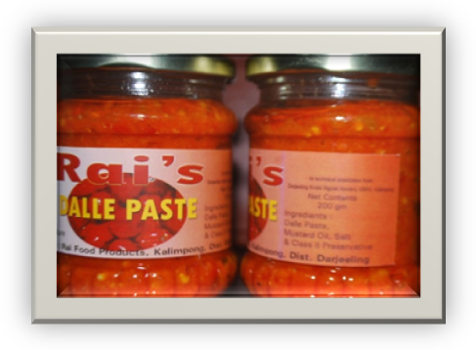

Food processing Industry in Darjeeling Hills is still underdeveloped. However, there are many traditional food items that are processed and produced which are specific to this region only. But unfortunately, even these specific items are not processed in commercial scale with scientific techniques. These regional items have good market both at home and abroad that needs immediate exploitation which has huge market potential in South East Asian countries. Under these circumstances, one Sri Ahok Rai, 43 years old from Sindaybong Busty near Kalimpong has come forward to take-up food processing as his profession. He was motivated after attending one of the training programme on Food Processing at Darjeeling Krishi Vigyan Kendra in 2009. He also took advice from Mr. S. P. Singh WBAS, Assistant Director of Horticulture, Department of Horticulture, Darjeeling Gorkha Hill Council, Kalimpong beside Krishi Vigyan Kendra and started his processing unit in a small scale taking technical help from Krishi Vigyan Kendra, Kalimpong in February 2010.

Source of Technology:
Darjeeling Krishi Vigyan Kendra and Department of Horticulture, Darjeeling Gorkha Hill Council, Kalimpong.

Production Capacity:
At present he is producing 1500 bottles of 250 grams each in every month.

Range of Products:
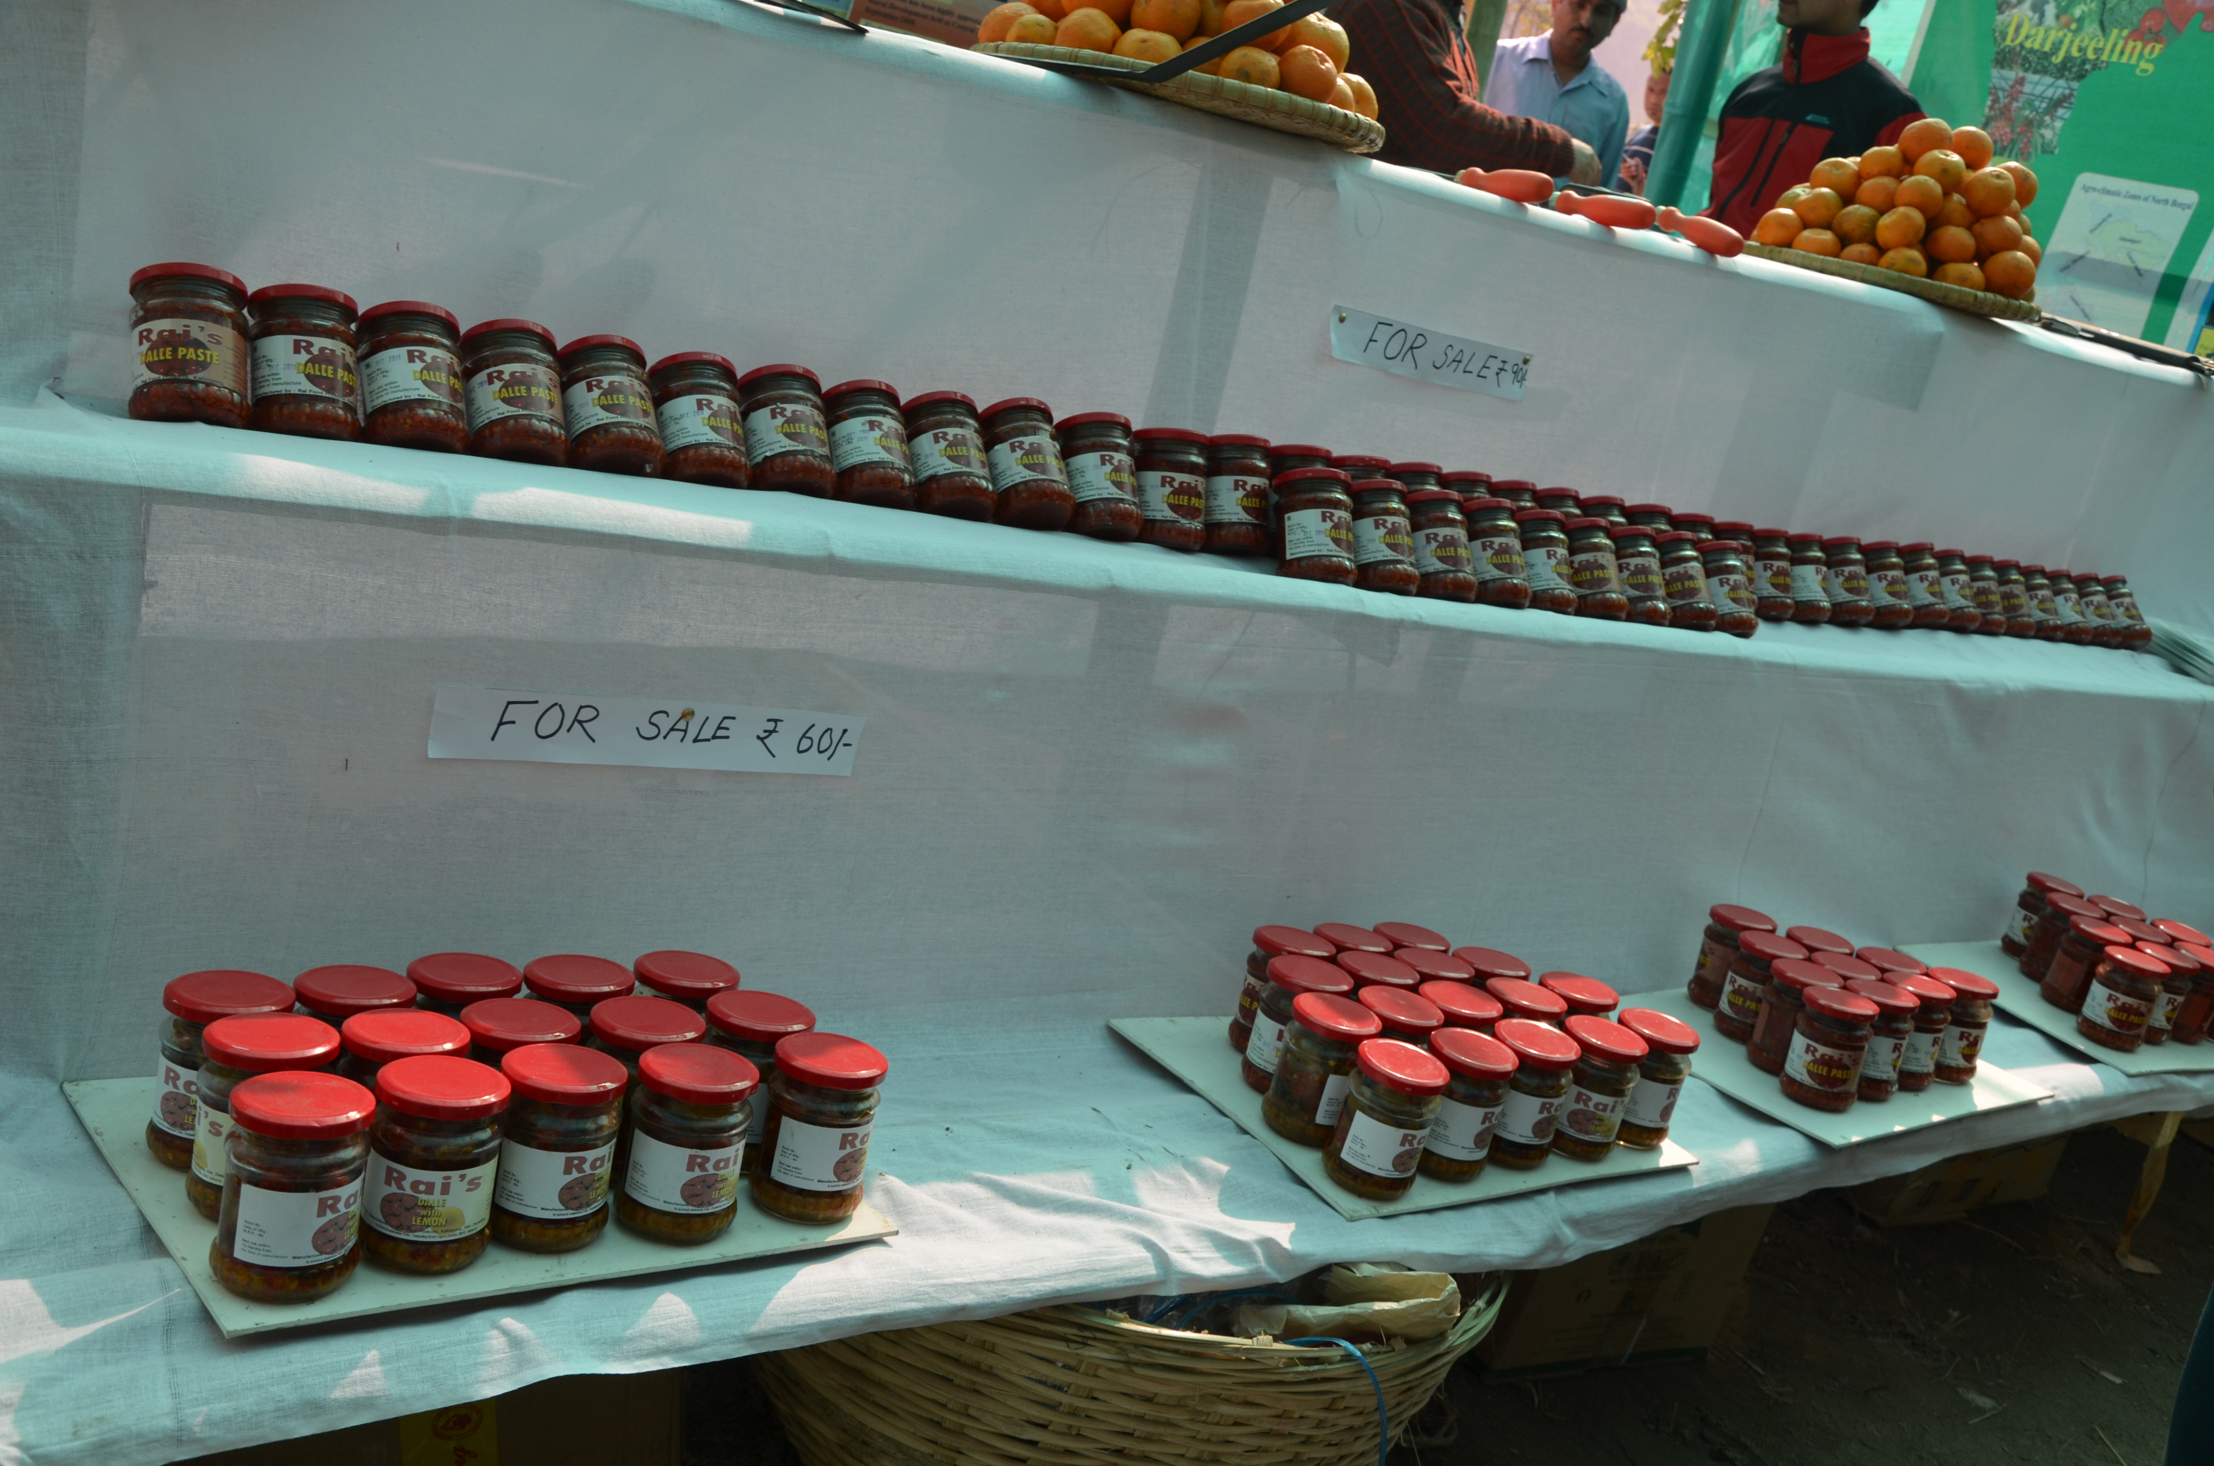
Sl.  No | Items | Rate for 250 gm bottle
1 | Dallay paste | ` 90
2 | Dallay paste with garlic and ginger | ` 90
3 | Dallay paste lemon | ` 70
4 | Dallay paste with bamboo shoot | ` 70
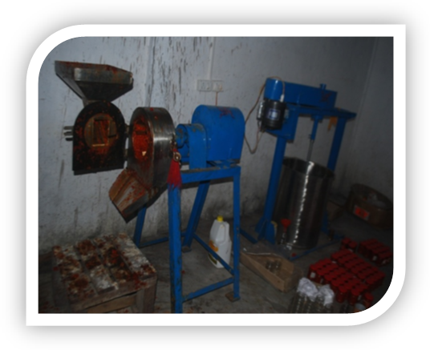
Machineries Procured:
He has procured the following machineries.
Fruit Miller
Mixing tank with stirrer
Manual capping machine
Citrus juice extractor

Market:
So far his products are sold only within the district of Darjeeling. However, it is also taken to Bhutan, Nepal and Sikkim by some people but in negligible quantity.
Distributer:
He has appointed only one distributor and is M/S Nilesh varieties Stores, Baghdhara Road, Kalimpong who distributes the product within Darjeeling District.

Area of the processing and Storage units:
Sri Rai has 25.00 sqr meter area for processing and the same areas for storage of the products.
Finance:
Sri Ashok Rai has taken loan of ` 3.5 lakh from Bank of India, Kalimpong Branch, Kalimpong while starting of the processing unit.

Finance:
Sri Rai has applied for the APO licence and expected to get shortly.
Employment Generated:
Sri Rai has not employed any permanent employee at the moment. He is handling all operations with the help of his family members. However, he is employing the seasonal labours on as and when required basis.

Problem:
Since his product is very good, some people are removing his label from the bottle and sticking their own and selling at higher rate in the market. Sri Rai is not able to take legal action to the culprits since he is still awaiting for APO licence.
Source of Inspiration:
Sri Ashok Rai is attracted to Food Processing Industry because of profitability and self sustainability of the industry.

Felicitation:
Very few farmers turn what is being said to them. Sri Ashok Rai was is one of them and Darjeeling Krishi Vigyan Kendra felicitated him on 11th January 2012 on the occasion of Krishi Paryatan Utsav 2012 held at Relli Tar, Kalimpong where is was honoured with khada by Sri Bimal Gurung, President, Gorkha Janmukti Morcha. He was presented the Letter of Recognition by Sri Anil Verma, Administrator, Darjeeling Gorkha Hill Council and a memento by Dr. Harka Bahadur Chettri, honourable MLA, Kalimpong.

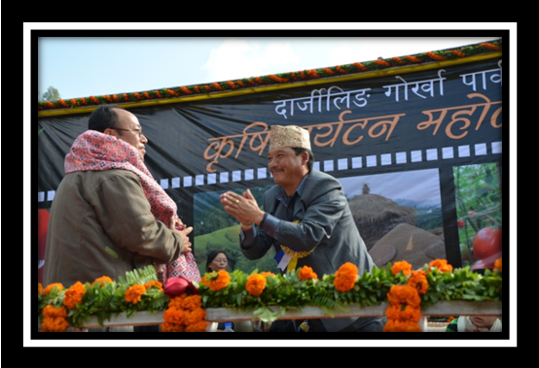

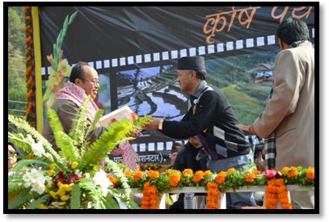
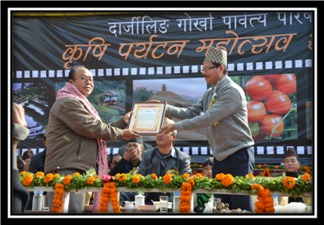

Message from Sri Ashok Rai

Shi Ashok Rai has a message to other fellow farmers -
Where there is Will, there is Way.

3.8. Give details of innovative methodology or innovative technology of Transfer of Technology developed and used during the year

Innovative methodology/technology used during this year

- Inarching of old Darjeeling Orange Orchards using trifoliate orange, rough lemon and Rangpur lime as rootstock to rejuvenate the plantation was well taken by the farmers.
- Management of Trunk Borer by injecting the pesticide on holes made by the larva and sealing of same hole with mud after injection was effective and less time consuming.
- Utilization of residual moisture after harvesting paddy for commercial cultivation of Gladiolus that helps in early production of cut flowers.
- Seed treatment of Ginger using hot water at 51⁰ C for 10 minutes for management of Rhozome rot disease.
- Management of bacterial wilt in Tomato using lime and bleaching powder has given good result.
- Sowing of Soybean on the canopy area of standing Darjeeling Plant as a green manure crop, helps in nutrient supply and check soil erosion.

3.9 Give details of indigenous technology practiced by the farmers in the KVK operational area which can be considered for technology development (in detail with suitable photographs)
S. No. | Crop / Enterprise | ITK Practiced | Purpose of ITK
1 | Rice | Brooming of rice plants when there is leaf folder incidence in the field. | To control leaf folder larvae,
2 | Cattle | Feeding of Ganja (Cannabis indica) Juice. | To control diarrohea.
3 | Management of soil acidity | Application of wood ash in soil. | To increase in soil acidity.
4 | Soybean | Preparation of fermented Soybean (Kinema). | Used as protein substitute.
5 | Rayo Sag (mustard) | Preparation of dry fermented vegetable for cooking soup, achar etc. | It is also appetizer and for emergency cooking.

3.10 Indicate the specific training need analysis tools/methodology followed by the KVK
Identification of courses for

- Farmers/farm women
- Rural Youth
- Inservice personnel

- Identification of courses for farmers/farm women
Interaction and discussion with the practicing farmers/farm women on their problems on different crops and animal husbandry. They placed their problems before the team of experts and the experts framed a training schedule for different problems. It was found that most of the problems were from the diseases and pests, soil management, irrigation and manures and fertilizer application.

  - Rural Youth

  - Rural youth were invited in an interaction programme where they were requested to write down the entrepreneurial programme they would take up if they are given financial and technical backup. All the participants presented their ideas and the entrepreneurship they would take up if an opportunity is given.

  - Inservice personnel

  - For inservice personnel, letter was given to the District Agricultural Officer and he had discussed the matter with his team on frequently encountered problem by his field level officers and that was communicated back to the Kendra.

3.11. a. Details of equipment available in Soil and Water Testing Laboratory

Status of establishment of Lab : Working
1. Year of establishment : 2005-06
2. List of equipments purchased with amount :

Sl. No | Name of the Equipment | Qty.
1. | Spectrophotometer | 1
2. | Flame Photometer | 1
3. | PH Meter | 1
4. | Conductivity bridge | 1
5. | Physical balance | 1
6. | Chemical balance | 1
7. | Digestion unit | 1
8. | Kjeldhal Distillation set | 2
9. | Mechanical shaker | 1
10. | Refrigerator | 1
11. | Hot air oven | 1
12. | Hot plate | 1
13. | Grinder | 1
14. | Water distillation unit (double) | 1
15. | Chemical and Glass wares
16. | Soxlet Apparatus (Big &Small) | 2
17. | Laboratory set up
18. | Soil and plant sample processing and storage facility
Total

3.11.b. Details of samples analyzed so far :
Details | No. of Samples | No. of Farmers | No. of Villages | Amount realized
Soil sample analysis | 775 | 561 | 37 | 0
Total | 775 | 561 | 37 | 0

3.12. Activities of rain water harvesting structure and micro irrigation system

No of training programme | No of demonstrations | No of plant material produced | Visit by the farmers | Visit by the officials

3.13 Technology week celebration

Type of activities | No. of activities | Number of participants | Related crop/livestock technology
Mela | 5 | 564

3.14. RAWE programme - is KVK involved?

No of student/ARS trained | No of days stayed

3.15. List of VIP visitors including the officials of ZPD and DEE

Date | Name of the person | Purpose of visit
08/04/2013 | Mrs. Madhumita Basu, Principal Account General, Govt. of West Bengal | --
11/06/2013 | Prof. Dr. Biswanath Bandyopadhyay, Hon’ble Vice chancellor, UBKV. | To look after the activities of KVK
09/01/2014 | Dr. Rohit Sharma, MLA Kurseong, GTA.  Dr. A K Banerjee, SSO, DST, Govt. of WB  Mr. P. Dutta, Acting Chairman  Mr. CC Dey,  Mr. M. A. Chatterjee  Mr. S Soren  Mr. M Bhoumik, WBSCST | Standing Committee, Rajya Sabha, Govt. of West Bengal
06/02/2014 | Dr. H Bhattacharya, DEE, UBKV | SAC Meeting
06/02/2014 | Dr. Debasis Majumdar, Director of Research, UBKV | SAC Meeting
06/02/2014 | Dr. F. H. Rehaman, Sr. Scientist, ZPD, ICAR | SAC Meeting
10/03/2014 | Dr. H Bhattacharya, DEE, UBKV | Technology Week

4.0 IMPACT

  - Impact of KVK activities (Not to be restricted for reporting period).

Name of specific technology/skill transferred | No. of participants | % of adoption | Change in income (Rs.)
Name of specific technology/skill transferred | No. of participants | % of adoption | Before (Rs./Unit) | After (Rs./Unit)
Management of Fruit fly in Darjeeling Mandarin | 125 | 23 | 1800 per plant | 3000 per plant
Nutrition Management in Darjeeling Mandarin | 253 | 33 | 2200 per plant | 3000 per plant
Management of trunk borer in Darjeeling Mandarin | 257 | 27 | In case of severe infection the entire plant will die
Off season vegetable cultivation under low cost polyhouse. | 221 | 36 | 20X20 polyhouse will return 20000 in the year round vegetable production

NB: Should be based on actual study, questionnaire/group discussion etc. with ex-participants

4.2 Cases of large scale adoption
(Please furnish detailed information for each case)
Horizontal spread of technologies
Technology | Horizontal spread

4.3 Details of impact analysis of KVK activities carried out during the reporting period

4.4 Details of innovations recorded by the KVK
Thematic area | Medicinal plant
Name of the Innovation | Commercial cultivation of Chirata
Details of Innovator | Shri Mani Chandra Rai, Age : 70 years, Education : BA, BT., Area : 5.5 acre, Farming experience : 55 years
Back ground of innovation | Chirauta (Swertia chirata) grows in wild in high altitude region and the people collect it sometimes to dried and keep in all households to use it whenever any family members gets fever. It works very well against fever and body ache. It is sold in the market also but it is treated illegal trade because it is considered as a wild crop and forest department does not permit for its collection and sell. So, Shri Rai has standardized its cultivation technique where the matured plants are harvested, dried on polythene sheets for easy collection of seeds.
Technology details | The seeds are sown in the nursery during February – March and two leaves stage by June and transplanted at a distance of 4 inches from plant to plant and 6 inches from row to row. Application of FYM @ 2 tons per acre is applied after the first hoeing and is properly mixed with soil with second hoeing where all weeds and stone pebbles are removed. These seedlings are weeded from time to time and remain intact in the same field where they attain six to seven leaf stages. They are allowed to continue to grow in the second year attain the height of 3 to 4 feet. To get maximum branching apical buds pinched off during early growth of second year. They bear flowers during September and seeds are matured by October-November. Once the plants are fully grown they are harvested during November and after sun drying they are ready for sale.
Practical utility of innovation | Sepi village in Rimbick region is high altitude located at an alleviation of 7000 feet from mean sea level where very few crops can be grown. Chirauta plant that grows in high altitude area is well suited here and grows in wild. It is tremendous market potential. With proper marketing the farmers of high altitude region will be able to earn handsome income through its cultivation. Total area under Chirauta 1 acre production 78 qnt. of dried Chirauta. The present market rate of dried Chirauta is Rs 250.

Thematic area | Vegetable Seed Tuber production
Name of the Innovation | Potato Seed Tuber production
Details of Innovator | Shri Birman Rai, Age : 69 years, Education : IV, Area : 4 acre, Farming experience : 53 years
Back ground of innovation | Sepi Busty in Rimbick, District of Darjeeling, being located in high altitude region is best suited for Potato seed tuber production. Since the identification of wart disease caused by fungus (Synchytrium endobioticum) in the year 1953 Potato Seed Tuber trade and has drastically reduced in the District. The Govt. has imposed ban on Potato Tuber Seed production in the District in 1959. But it was the only cash crop in a remote village like Sepi. Shri Rai carried on with potato seed tuber production and is still producing Seed Tubers without any incidence of wart disease for the past 53 years.
Technology details | He applies 7 tons of FYM before planting along with NPK @ 80:60:80 kg/ha in the form of Sufala and additional Nitrogen through Urea. He grows B-2 and B. T. varieties. The second variety is collected from Nepal that gives very good yield. A single potato tuber weighs up to 500 grams, taste better with yield potential of 1:16. Planting is done in December/January with a single weeding in April. Irrigation is given 3 to 4 times depending on the requirements. Sometimes, the problem of blight do appear at the time of germination itself. However, so far there is no serious damage due to this disease. The crop is harvested during June-July and grading is done where bigger and smaller tubers are separated. Bigger ones are sold as vegetable which is sold at cheaper rate (Rs.15 per kg) and the smaller tubers are sold as seed tubers that fetches better price (Rs. 25 per kg).
Practical utility of innovation | As mentioned above potato grown in Darjeeling district cannot be taken anywhere in India and abroad because of wart disease problem but Shri Rai is growing potato without any incidence of wart disease and over 85 farm families are also following his technique of growing and selling potato seed tuber in other district of West Bengal, Bihar and Uttar Pradesh.
4.5 Details of entrepreneurship development

Entrepreneurship development
Name of the enterprise
Name & complete address of the entrepreneur
Intervention of KVK with quantitative data support:

Time line of the entrepreneurship development

Technical Components of the Enterprise

Status of entrepreneur before and after the enterprise
Present working condition of enterprise in terms of raw materials availability, labour availability, consumer preference, marketing the product etc. ( Economic viability of the enterprise):
Horizontal spread of enterprise

4.6 Any other initiative taken by the KVK

5.0 LINKAGES

5.1 Functional linkage with different organizations

Name of organization | Nature of linkage
State Agriculture Dept., Govt. of West Bengal | Training
Regional Research Station (Hill Zone), Uttar Banga Krishi Viswavidyalaya, Kalimpong | Training
Dept. of Animal Recourses Development, Govt. of West Bengal | Training
Sasastra Seema Bal (SSB), Siliguri Frontier | Training
Regional Station, Indian Agricultural Research Institute, Kalimpong | Training
Regional Research Station (Hill Zone), Uttar Banga Krishi Viswavidyalaya, Kalimpong | Demonstration
State Agriculture Dept., Govt. of West Bengal | Demonstration
Regional Research Station (Hill Zone), Uttar Banga Krishi Viswavidyalaya, Kalimpong | Joint Survey
State Agriculture Dept., Govt. of West Bengal | Joint Survey
State Agriculture Dept., Govt. of West Bengal | Technical Support
Regional Research Station (Hill Zone), Uttar Banga Krishi Viswavidyalaya, Kalimpong | Technical Support
Dept. of Animal Recourses Development, Govt. of West Bengal | Technical Support
Spices Board, Kalimpong, Govt. of India | Technical Support
Regional Station, Indian Agricultural Research Institute, Kalimpong | Technical Support
5.2. List special programmes undertaken during 2013-14 by the KVK, which have been financed by ATMA/ Central Govt/ State Govt./NHM/NFDB/Other Agencies (information of previous years should not be provided)

a) Programmes for infrastructure development

Name of the programme/scheme | Purpose of programme | Date/ Month of initiation | Funding agency | Amount (Rs.)
Total

(b) Programme for other activities (training, FLD,OFT, Mela, Exhibition etc.)

Name of the programme/scheme | Purpose of programme | Date/ Month of initiation | Funding agency | Amount (Rs.)
Micro Irrigation & Polyhouse Cultivation | Capacity Building | 29/Nov 2013 | DST, Govt. of W.B. | 10,000/-
Krishi Mela at Relli | Awareness | 13-15 Jan 2014 | GTA | 1,06000/-
Cultivation of Mushroom & food Preservation | Capacity Building | 06-12 Jan 2014 & 14-19Jan 2014 | Office of the DM | 1,79,000/-
Training of Headmasters of Farm School | Capacity Building | 17-22 Jan 2014 | ATMA | 75,500/-
Training of Headmasters of Farm School | Capacity Building | 03-05 Jan 2014 | World Vision | 10,000/-

- PERFORMANCE OF INFRASTRUCTURE IN KVK

6.1 Performance of demonstration units (other than instructional farm)

Sl. No. | Name of demo Unit | Year of estt. | Area(Sq.mt) | Details of production |  |  | Amount (Rs.) |  | Remarks
 |  |  |  | Variety/breed | Produce | Qty. | Cost of inputs | Gross income | Remarks
1. | Piggery | 2012 | 16 | Yorkshire & Ghugroo | Piglets | 22 | 25000 | 52600
2. | Piggery | 2012 | 16 | Yorkshire & Ghugroo | Live sale | 3 | 15000 | 28500
3. | Goatery | 2012 | 9 | Black Bengal | Live sale | 6 | 5800 | 10500
4. | Poultry | 2012 | 18 | White leghorn & Ban raja | Live sale | 16 | 3400 | 5688
5.
6.

6.2 Performance of instructional farm (Crops)
Name  Of the crop | Date of sowing | Date of harvest | Area (ha) | Details of production |  |  | Amount (Rs.) |  | Remarks
 |  | Date of harvest | Area (ha) | Variety | Type of Produce | Qty.(q) | Cost of inputs | Gross income | Remarks
Paddy | 16.7.13 | 28.11.13 | 0.5 | Adday (Local) | Cereals | 4.34 | 5500 | 8700
Potato | 07.12.13 | 26.02.13 | 0.5 | Laal gulal (Punjab) | Tubers | 8.12 | 6000 | 10632
Broom Stick | 10.06.13 | 03.02.13 | 1.0 | Local |  | 3.57 | 3000 | 10650

  - Performance of Production Units (bio-agents / bio pesticides/ bio fertilizers etc.,)

Sl.  No. | Name of the Product | Qty (Kg) | Amount (Rs.) |  | Remarks
Sl.  No. | Name of the Product | Qty (Kg) | Cost of inputs | Gross income | Remarks
1.

  - Performance of instructional farm (livestock and fisheries production)

Sl.  No | Name  of the animal / bird / aquatics | Details of production |  |  | Amount (Rs.) |  | Remarks
Sl.  No | Name  of the animal / bird / aquatics | Breed | Type of Produce | Qty. | Cost of inputs | Gross income | Remarks
1.
2
3

6.5 Utilization of hostel facilities

Accommodation available (No. of beds): 35

Months | No. of trainees stayed | Trainee days (days stayed) | Reason for short fall (if any)
April 2013 | 4 | 2
May 2013
June 2013 | 25 | 8
July 2013 | 36 | 3
August 2013
September 2013 | 35 | 5
October 2013
November 2013 | 26 | 5
December 2013 | 41 | 5
January 2014 | 75 | 7
February 2014 | 80 | 7
March 2014 | 112 | 7
(For whole of the year)

  - Utilization of staff quarters

Whether staff quarters has been completed: Yes
No of staff quarters: 6
Date of completion: 2008-09

Occupancy details
Months | Q I | QII | Q III | QIV | Q V | QVI
Dec 2009 to till date | B1
March 2010 to till date |  | C2
February 2012 till date |  |  | C1
Feb 2014 to till date |  |  |  | B2
Vacant |  |  |  |  | B3
Vacant |  |  |  |  |  | A1

7.FINANCIAL PERFORMANCE

7.1 Details of KVK Bank accounts

Bank account | Name of the bank | Location | Account Number
With Host Institute
With KVK | State Bank of India | Kalimpong | 11283931150
With KVK | Bank of India | Kalimpong | 429310110000033

  - Utilization of funds under FLD on Oilseed (Rs. In Lakhs)

Item | Released by ICAR |  | Expenditure |  | Unspent balance as on -
Item | Kharif | Rabi | Kharif | Rabi | Unspent balance as on -

7.3 Utilization of funds under FLD on Pulses (Rs. In Lakhs)
Item | Released by ICAR |  | Expenditure |  | Unspent balance as on 1st April 2013
Item | Kharif | Rabi | Kharif | Rabi | Unspent balance as on 1st April 2013

7.4 Utilization of funds under FLD on Maize (Rs. In Lakh)

Item | Released by ICAR |  | Expenditure |  | Unspent balance as on 1st April 2014
Item | Kharif | Rabi | Kharif | Rabi | Unspent balance as on 1st April 2014
Maize | 49,500/- |  | 49,500/- |  | Nil
TOTAL | 49,500/- |  | 49,500/- |  | Nil

7.5 Utilization of KVK funds during the year 2013 -14 (Not audited)
S.  No. | Particulars | Sanctioned | Released | Expenditure
A. Recurring Contingencies
1 | Pay & Allowances | 52,50,000 | 52,50,000 | 51,40665
2 | Traveling allowances | 1,50,000 | 1,50,000 | 1,49,924
3 | Contingencies
A | Stationary, Telephone, Postage and other office expenses | 5,00,000 | 5,00,000 | 4,99,976
B | POL, Repair of vehicles, tractor and equipment | 5,00,000 | 5,00,000 | 4,99,976
C | Training of farmers | 3,50,000 | 3,50,000 | 3,49,952
D | Training materials (Posters, charts, demonstration materials including chemical etc. required for conducting training | 3,50,000 | 3,50,000 | 3,49,952
E | Training of Extension functionaries | 3,50,000 | 3,50,000 | 3,49,952
F | Training of Rural youth | 3,50,000 | 3,50,000 | 3,49,952
G | Frontline Demonstration (Minimum of 100 demonstration in a year) | 1,50,000 | 1,50,000 | 149783
H | On Farm Testing (On need based, Location specific and newly generated information in the major production system of the year | 1,00,000 | 1,00,000 | 99,832
I | Soil and water testing | -- | -- | --
J | Maintainance of building | 50,000 | 50,000 | 49,998
TOTAL (A) |  | 65,50,000 | 65,50,000 | 64,40,130
B. Non-Recurring Contingencies
1 | Works () | -- | -- | --
2 | Vehicle | -- | -- | --
3 | Equipment, furniture and Furnishing | -- | -- | --
4 | Soil & water testing equipments | -- | -- | --
TOTAL (B) |  | -- | -- | --
C. REVOLVING FUND |  | -- | -- | --
GRAND TOTAL (A+B+C) |  | 65,50,000 | 65,50,000 | 64,40,130

7.6. Status of revolving fund (Rs. in lakh) for last three years
Year | Opening balance as on 1st April | Income during the year | Expenditure during the year | Net balance in hand as on 1st April of each year (Kind + cash)
2011-12 | 1,16,825 | 1,15,282 | 1,43,565 | 88,542
2012-13 | 88,542 | 1,16,903 | 5,185 | 2,00,260
2013-14 | 1,12,633 | 49,655 | 14,263 | 1,76,551

7.6.(i) Number of SHGs formed by KVKs (ii) association of KVKs with SHGs formed by other organizations indicating the area of SHG activities.

  - Details of marketing channels created for the SHGs

  - Special programme on Food and Nutrition :

  - Community Radio Station :

  - Joint activity carried out with line departments and ATMA

Name of activity | Season | With line department | With ATMA | Both
Training of Headmasters of Farm School | -- | Deptt. of Agriculture
 |  | Spices Board of India
 |  | RRS (Hill Zone)
 |  | IARI, Kalimpong

8. Other information

8.1. Prevalent diseases in Livestock/Crops

Name of the disease | Crop/animal | Date of outbreak | Number of death/ % crop loss | Number of animals vaccinated

8.2. Nehru Yuva Kendra (NYK) Training

Title of the training programme | Period |  | No. of the participant |  | Amount of Fund Received (Rs)
 | From | To | M | F

8.3. PPV & FR Sensitization training Programme
Date of organizing the programme | Resource Person | No. of participants | Registration (crop wise)
 |  |  | Name of crop | No. of registration
10/03/2014 | Dr. H Bhattacharya  DEE, UBKV | 25 | -- | --
 | Mr. M.S. Ramalingam, Asst. Director, Spices Board of India, Kalimpong | 25 | -- | --
 | Dr. B. R. Sharma, In-Charge, RRS (Hill Zone) Kalimpong | 25 | -- | --
 | Dr. Kausik Majumdar  ADA (Research), Dept. Of Agi., Kalimpong | 25 | -- | --

8.4. KMAS /SMS Portal
KISAN MOBILE ADVISORY SERVICE
No. of calls | No. of farmers covered | No. of messages | Types of messages (No.)
No. of calls | No. of farmers covered | No. of messages | Crop | Livestock | Weather | Marketing | Awareness | Other

8.5. SMS PORTAL
Date of start of functioning of SMS portal
No. of messages | No. of calls | No. of farmers covered | Types of messages (No.)
No. of messages | No. of calls | No. of farmers covered | Crop | Livestock | Weather | Marketing | Awareness | Other
29 | 53 | 6275 | 1325 | 4500 |  |  | 450

8. 6.Programme with Seema Suraksha Bal (BSF)
Title of Programme | Date | No. of participants

8.7. a. Utilization of HRD fund (Rs 0.50 Lakh provided to KVKs)
Training programme/ Seminar/ Symposia/ Workshop etc attended | Duration | Name of the  participants | Designation | Organizer of the training Programme | Amount spent for the purpose (Rs.)

b. HRD fund utilized for other purposes
Head | Amount (Rs.)

8.8. Performance of Automatic Weather Station in KVK
Date of establishment | Source of funding i.e. IMD/ICAR/Others (pl. specify) | Present status of functioning

8.9. IPNI Trail (Applicable for KVKs identified under IPNI trial)
I Name of Crop
II No. of farmers involved
III Area (ha.)
IV Date of sowing
V Crop Season
VI Result of trial with photographs however detailed results/observation should be
sent as per performance after crop harvest
VII Amount Spent

8.10. Achievement under TSP Project (Saraikella, Godda, Sahibganj, Dumka, Giridih,, Pakur)
Name of the village adopted under TSP | Block | Population of the village |  |  | ST Population of the village |  |  | Percentage of ST population to total population
 |  | M | F | T | M | F | T
Details of Activities under TSP Project
Activities |  | No. of participants |  |  | Approx. expenditure (Rs.)
 |  | M | F | T
No. of on-farm trials
Frontline demonstrations
Farmers trained
No of extension activities
Input made available
Seed (q)
Planting material (No)
Livestock strains and finger lings
No of poultry, duck, pig, goat provided
No of farm implements provided
Others, if any, please specify
Exposure visit
Exhibition
Kisan Mela

8.11 Progress Report OF NICRA KVK (Technology Demonstration component ) 2013-14
(Applicable for KVKs identified under NICRA)

Natural Resource Management
Name of intervention undertaken | Numbers under taken | No of units | Area (ha) | No of farmers covered / benefitted | Remarks

Crop Management
Name of intervention undertaken | Area (ha) | No of farmers covered / benefitted | Remarks

Livestock and fisheries
Name of intervention undertaken | Number of animal covered | Number of units | Area (ha) | No of farmers covered / benefitted | Remarks

Institutional interventions
Name of intervention undertaken | No of units | Area (ha) | No of farmers covered / benefitted | Remarks

Capacity building
Thematic area | No. of Courses | No. of beneficiaries
Thematic area | No. of Courses | Males | Females | Total

Extension activities
Thematic area | No. of activities | No. of beneficiaries
Thematic area | No. of activities | Males | Females | Total
Detailed report should be provided in the circulated Performa

8.12. National Initiative on Fodder Technology Demonstration (NIFTD)
(Applicable for KVKs identified under NIFTD)

Name of the fodder crop | Date of sowing | Area (ha) | No. of farmers  involved | Demonstration  Yield (q/ha) |  |  | Check Yield |  |  | % increase
 |  |  |  | H | L | A | H | L | A

Economic of Demonstration
Name of the fodder crop | Demonstration Cost/Rs/ha |  |  | Check Cost (Rs/ha)
 | Gross cost | Gross return | BC ratio | Gross cost | Gross return | BC ratio

8.13. Awards/Recognition received by the KVK

Sl. No. | Name of the Award | Year | Conferring Authority | Amount | Purpose
Award received by Farmers from the KVK district
Sl. No. | Name of the Award | Name of the Farmer | Year | Conferring Authority | Amount | Purpose

